文件编号：RD

发布单位：IC研发部
发布对象：IC研发部
发布尔日期：
生效日期：

SG2260 GDMA Design Spec

注意
本文件所含信息均具有保密性质并仅限于内部使用。不得对本文件、本文件的任何部分或本文件所含的任何信息进行未经授权地使用、披露或复制。
NOTICE
The information contained in this document is confidential and is intended only for internal use. Unauthorized use, disclosure or copying of this document, any part hereof or any information contained herein is strictly prohibited.

修订记录
版本号 | 修订日期 | 作者 | 修订内容
1.0 | 2023.12.15 | ConsonYao | 初始制作

目 录
1 Overview 5
1.1 Terms and Abbreviations 5
1.2 Function Block 5
1.3 Feature and Parameters 5
2 Architecture 7
2.1 Architecture diagram 7
2.2 Architecture Description 7
2.3 SDMA Description 7
3 Interface 9
3.1 Interface Signal Description 9
3.2 Integration requirement 13
4 Clock and Reset 15
4.1 Clock 15
4.2 Reset 15
5 Internal Blocks 16
5.1 Working Flow 16
5.2 Internal block description 16
5.2.1 DES Module 17
5.2.2 Gdma_sys_ctrl Module 19
5.2.3 matrix Module 19
5.2.4 cw_transpose Module 22
5.2.5 lossless compress Module 23
5.2.6 lossless decompress Module 26
5.2.7 lossy compress Module 28
5.2.8 lossy decompress Module 29
5.2.9 gather_ scatter Module 30
5.2.10 general_reverse Module 31
5.2.11 maskselect_nonzero Module 36
5.2.12 tensor Module 37
5.2.13 RDMA Module 41
5.2.14 WDMA Module 43
5.2.15 GIF/DTN interface Module 44
6 Register description 45
7 Software Program Guide 67
8 CDC 67
9 Synthesis Guide 67
10 PD Guide 69
11 Known Issues and Future Work 69

Overview

Terms and Abbreviations
序号 | 术语 | 定义说明
 | LMEM | Local Memory
 | GMEM | Global Memory(DRAM)
 | Cen_RDMA | centralize Read DMA
 | Cen_WDMA | centralize Write DMA
表1-1 术语定义表

Function Block
图 1-1 Function Block

Feature and Parameters
内部数据处理feature:
GDMA内部支持1024 bit 数据流位宽
GDMA内部处理速度为1GHz，数据处理throughput为1024bit per cycle
支持RDMA/WDMA乱序重组(相同request的out of order 及 不同request的interleave)
内部共计三组RDMA及三组WDMA，内部透过arbiter共享对外DTN及Gif接口
指令IP功能支持 transfer、matrix、cw_transpose、general、reverse、randmask、lossy/lossless compress and decompress、mask_select、non-zero等等。(各指令功能描述需参考TPU 指令级文文件)
(code) CMD_TYPE | CMD description
(0x0) GDMA_tensor | NCHW数据型态整型及数据搬移
(0x1) GDMA_matrix | 2维数据型态整型及数据搬移
(0x2) GDMA_masked_select | 对数据进行屏蔽并搬移
(0x3) GDMA_general | 1维数据型态整型及数据搬移
(0x4) GDMA_CW_transpose | CW数据型态转置及数据搬移
(0x9) GDMA_reverse | NCHW数据型态反向重排及数据搬移
(0x5) GDMA_nonzero | NCHW数据型态二值化处理及数据搬移
(0x7) GDMA_gather | NCHW数据型态聚合及数据搬移
(0x8) GDMA_scatter | NCHW数据型态发散映像及数据搬移
(0xa) GDMA_compress | NCHW数据型态压缩处理及数据搬移
(0xb) GDMA_decompress | NCHW数据型态解压缩处理及数据搬移
(0xc) GDMA_lossy_compress | NCHW数据型态有损压缩处理及数据搬移
(0xd) GDMA_lossy_decompress | NCHW数据型态有损解压缩处理及数据搬移
表1-2 指令IP列表

对外资料存取带宽feature:
Bus转换后的对外DTN及Gif接口均为1024 bit位宽
GDMA对外接口处理速度为1GHz
GDMA理想满载带宽为128GB/s
GDMA max outstanding = 128，max burst length = 2
Base address支持Byte alignment
DES 模块feature:
透过AXI master支持DES mode
透过AXI slave支持PIO mode及CSR操作。
支持一组64bit A4S master接口，用于传递msg sync信息。
支持一组128bit AXI master接口，用于DES模式下读指令及PMU写出log。
支持最多缓存17条PMU信息。

Architecture

Architecture diagram

图 2‑1 GDMA Architecture Overview

Architecture Description
GDMA系统主要为TPU这类大算力单元做数据排列方式整形、资料搬移、压缩解压缩等预处理，一般主要将数据于DRAM、L2M及Local MEM(简称LMEM)做不同tensor型态的转换或是数据的压缩解压缩及排列重组。以下为GDMA的内部模块组成:
- DES: 负责执行descriptor及PIO模式操作
- sys_ctrl: 负责驱动datapath模块中的指令IP
- datapath: 内部包含多个指令IP(见表1.3-1)，每次只能操作一个指令IP
- Cen_RDMA: 负责对外发送存取DRAM、L2M、Local MEM等需求的request及接收读回数据。内部走线为AXI bus。
- Cen_WDMA: 负责对外发送存取DRAM、L2M、Local MEM等需求的request及发送写出数据。内部走线为AXI bus。
- AXI Fabric: 负责区分Cen_RDMA及Cen_WDMA发出的address对外的接口类别，将相应的request发送至后面的AXI_to_DTN或AXI_to_Gif。
- AXI_to_DTN: 将内部AXI bus的command转换为对外的DTN bus。
- AXI_to_DTN: 将内部AXI bus的command转换为对外的Gif bus。

SDMA Description
SDMA为GDMA的一个subset，透过parameter设定来定义lite哪些指令IP，精简版的GDMA即为SDMA。
SDMA相比于GDMA有些指令的删减，并且由于SDMA没有与TPU的直连接口，其sync_id与gif街口均为无用接口。SDMA与GDMA指令的对比如表所示。
表 GDMA VS SDMA INSTRUCTION
INSTRUCTION | GDMA | SDMA
tensor | ✔ | ✔
matrix | ✔
masked_select | ✔
general | ✔ | ✔
cw_transpose | ✔
nonzero | ✔
gather | ✔ | ✔
scatter | ✔ | ✔
reverse | ✔
compress | ✔
decompress | ✔
lossy_compress | ✔ | ✔
lossy_decompress | ✔ | ✔
表2-1 GDMA/SDMA指令差异

Interface

Interface Signal Description
Function | Name | Width | Direction | description
Clock & Reset | aclk | 1 | in | 工作时钟信号
 | aresetn | 1 | in | 复位信号，active low
power shutdown ctrl | pwr_shutdown_short_x_i | 1 | in | power shutdown ctrl, active low
 | pwr_shutdown_short_x_o | 1 | out | power shutdown output
 | pwr_shutdown_long_x_i | 1 | in | power shutdown ctrl, active low
 | pwr_shutdown_long_x_o | 1 | out | power shutdown output
 | pwr_iso_i | 1 | in | pwr iso cell crtl, high is power down
Core ID | x_id | 3 | in | 表示该gdma在网络拓扑中的X方向ID
 | x_id | 3 | in | 表示该gdma在网络拓扑中的Y方向ID
Sync ID | sync_in | 32 | in | 从 TPU 传来的 sync id
 | sync_out | 32 | out | 传给 TPU 的 sync id
Debug Signal | gdma_dbg_mod_sel | 8 | in | gdma 内 debug 模块选择
 | gdma_dbg_sig_sel | 8 | in | gdma 内 debug 模块信号选择
 | gdma_dbg_bus | 32 | out | gdma 内 debug 信号输出
Interrupt | gdma_interrupt | 1 | out | gdma normal interrupt, level
 | gdma_err_intr | 1 | out | gdma error interrupt, level
Performance Monitor enable | gdma_monitor_en | 1 | in | Performance Monitor enable, active high
A4S master interface | rxa4stready | 1 | in | rxa4stready for msg central
 | rxa4stvalid | 1 | in | rxa4stvalid for msg central
 | rxa4stdest | 8 | in | rxa4stdest for msg central
 | rxa4stid | 8 | in | rxa4stid for msg central
 | rxa4stdata | 64 | in | rxa4stdata for msg central
 | rxa4ststrb | 8 | in | rxa4ststrb for msg central
 | rxa4stkeep | 8 | in | rxa4stkeep for msg central
 | rxa4stlast | 1 | in | rxa4stlast for msg central
 | txa4stready | 1 | in | txa4stready for msg central
 | txa4stvalid | 1 | out | txa4stvalid for msg central
 | txa4stdest | 8 | out | txa4stdest for msg central
 | txa4stid | 8 | out | txa4stid for msg central
 | txa4stdata | 64 | out | txa4stdata for msg central
 | txa4ststrb | 8 | out | txa4ststrb for msg central
 | txa4stkeep | 8 | out | txa4stkeep for msg central
 | txa4stlast | 1 | out | txa4stlast for msg central
Configure AXI slave Interface | s_axi_arvalid | 1 | in | gdma_reg读地址有效
 | s_axi_arready | 1 | out | gdma_reg读地址有效
 | s_axi_araddr | 16 | in | tpu_des读地址
 | s_axi_arid | 12 | in | gdma_reg读地址id
 | s_axi_arlen | 4 | in | gdma_reg读地址突发长度
 | s_axi_arsize | 3 | in | gdma_reg读地址突发大小
 | s_axi_arburst | 2 | in | gdma_reg读地址突发类型
 | s_axi_arlock | 1 | in | gdma_reg读地址锁定类型
 | s_axi_arcache | 4 | in | gdma_reg读地址cache类型
 | s_axi_arprot | 3 | in | gdma_reg读地址保护类型
 | s_axi_arqos | 4 | in | gdma_reg读地址transaction优先级
 | s_axi_rvalid | 1 | out | gdma_reg读数据有效
 | s_axi_rready | 1 | in | gdma_reg读数据ready
 | s_axi_rdata | 128 | out | gdma_reg读数据
 | s_axi_rid | 12 | out | gdma_reg读数据id
 | s_axi_rresp | 2 | out | gdma_reg读数据回应信号
 | s_axi_rlast | 1 | out | gdma_reg读数据最后数据
 | s_axi_awvalid | 1 | in | gdma_reg写地址有效
 | s_axi_awready | 1 | out | gdma_reg写地址ready信号
 | s_axi_awaddr | 16 | in | gdma_reg写地址
 | s_axi_awid | 12 | in | gdma_reg写地址id
 | s_axi_awlen | 4 | in | gdma_reg写地址突发长度
 | s_axi_awsize | 3 | in | gdma_reg写地址突发大小
 | s_axi_awburst | 2 | in | gdma_reg写地址突发类型
 | s_axi_awlock | 1 | in | gdma_reg写地址锁定类型
 | s_axi_awcache | 4 | in | gdma_reg写地址cache类型
 | s_axi_awprot | 3 | in | gdma_reg写地址保护类型
 | s_axi_awqos | 4 | in | gdma_reg写地址transaction优先级
 | s_axi_wvalid | 1 | in | gdma_reg写数据有效
 | s_axi_wready | 1 | out | gdma_reg写数据ready信号
 | s_axi_wdata | 128 | in | gdma_reg写数据
 | s_axi_wstrb | 16 | in | gdma_reg写数据字节使能信号
 | s_axi_wlast | 1 | in | gdma_reg写数据最后数据
 | s_axi_bvalid | 1 | out | gdma_reg写响应有效
 | s_axi_bready | 1 | in | ingdma_reges写响应ready
 | s_axi_bid | 12 | out | gdma_reg写响应id
 | s_axi_bresp | 2 | out | gdma_reg写响应
Descriptor & PMU AXI master Interface | m_ddr_arvalid | 1 | out | gdma_des读地址有效
 | m_ddr_arready | 1 | in | gdma_des读地址有效
 | m_ddr_araddr | 40 | out | gdma_des读地址
 | m_ddr_arid | 4 | out | gdma_des读地址id
 | m_ddr_arlen | 4 | out | gdma_des读地址突发长度
 | m_ddr_arsize | 3 | out | gdma_des读地址突发大小
 | m_ddr_arburst | 2 | out | gdma_des读地址突发类型
 | m_ddr_arlock | 1 | out | gdma_des读地址锁定类型
 | m_ddr_arcache | 4 | out | gdma_des读地址cache类型
 | m_ddr_arprot | 3 | out | gdma_des读地址保护类型
 | m_ddr_arqos | 4 | out | gdma_des读地址transaction优先级
 | m_ddr_rvalid | 1 | in | gdma_des读数据有效
 | m_ddr_rready | 1 | out | gdma_des读数据ready
 | m_ddr_rdata | 128 | in | gdma_des读数据
 | m_ddr_rid | 4 | in | gdma_des读数据id
 | m_ddr_rresp | 2 | in | gdma_des读数据回应信号
 | m_ddr_rlast | 1 | in | gdma_des读数据最后数据
 | m_ddr_awvalid | 1 | out | gdma_pmu写地址有效
 | m_ddr_awready | 1 | in | gdma_pmu写地址ready信号
 | m_ddr_awaddr | 40 | out | gdma_pmu写地址
 | m_ddr_awid | 4 | out | gdma_pmu写地址id
 | m_ddr_awlen | 4 | out | gdma_pmu写地址突发长度
 | m_ddr_awsize | 3 | out | gdma_pmu写地址突发大小
 | m_ddr_awburst | 2 | out | gdma_pmu写地址突发类型
 | m_ddr_awlock | 1 | out | gdma_pmu写地址锁定类型
 | m_ddr_awcache | 4 | out | gdma_pmu写地址cache类型
 | m_ddr_awprot | 3 | out | gdma_pmu写地址保护类型
 | m_ddr_awqos | 4 | out | gdma_pmu写地址transaction优先级
 | m_ddr_wvialid | 1 | out | gdma_pmu写数据有效
 | m_ddr_wready | 1 | in | gdma_pmu写数据ready信号
 | m_ddr_wdata | 128 | out | gdma_pmu写数据
 | m_ddr_wstrb | 16 | out | gdma_pmu写数据字节使能信号
 | m_ddr_wlast | 1 | out | gdma_pmu写数据最后数据
 | m_ddr_bvalid | 1 | in | gdma_pmu写响应有效
 | m_ddr_bready | 1 | out | gdma_pmu写响应ready
 | m_ddr_bid | 12 | in | gdma_pmu写响应id
 | m_ddr_bresp | 2 | in | gdma_pmu写响应
DTN interface | TXREQFLITPEND | 1 | out | TransmitterRequest Early Flit Valid hint
 | TXREQFLITV | 1 | out | Transmitterrequest flit valid
 | TXREQFLIT | 109 | out | Transmitterrequest flit
 | TXREQLCRDV | 1 | in | TransmitterRequest channel link layer credit
 | TXDATFLITPEND | 1 | out | Transmitter Data Early Flit Valid hint
 | TXDATFLITV | 1 | out | Transmitter Data flit valid
 | TXDATFLIT | 1321 | out | Transmitter Data flit
 | TXDATLCRDV | 1 | in | TransmitterData channel link layer credit
 | RXRSPFLITPEND | 1 | in | Receiverr Resp Early Flit Valid hint
 | RXRSPFLITV | 1 | in | Receiver Resp flit valid
 | RXRSPFLIT | 47 | in | Receiver Resp flit
 | RXRSPLCRDV | 1 | out | ReceiverResp channel link layer credit
 | RXDATFLITPEND | 1 | in | Receiver Data Early Flit Valid hint
 | RXDATFLITV | 1 | in | Receiver Data flit valid
 | RXDATFLIT | 1321 | in | Receiver Data flit
 | RXDATLCRDV | 1 | out | ReceiverData channel link layer credit
Gif Master Interface To TPU | gif_lmem0_maddr | 35 | out | Write/Read Address to TPU
 | gif_lmem0_mread | 1 | out | Read transaction to TPU
 | gif_lmem0_mwrite | 1 | out | Write transaction to TPU
 | gif_lmem0_mid | 11 | out | ID tag to TPU
 | gif_lmem0_msize | 3 | out | Burst size to TPU
 | gif_lmem0_mburst | 2 | out | Burst type to TPU
 | gif_lmem0_mlen | 8 | out | Burst length to TPU
 | gif_lmem0_mlast | 1 | out | Last data in a burst to master
 | gif_lmem0_mdata | 1024 | out | 1024-bit data to TPU
 | gif_lmem0_mwstrb | 128 | out | Write strobes from to TPU
 | gif_lmem0_mready | 1 | out | Ready signal to TPU
 | gif_lmem0_sid | 11 | in | ID tag to TPU
 | gif_lmem0_saccept | 1 | in | Accept signal from TPU
 | gif_lmem0_svalid | 1 | in | Valid signal from TPU
 | gif_lmem0_sdata | 1024 | in | 1024-bit Data from TPU
 | gif_lmem0_sresp | 2 | in | Response signal from TPU
 | gif_lmem0_slast | 1 | in | Last data from TPU

表 3‑1：gdma top interface description

Integration requirement
GDMA的parameter设置如下:

SDMA_UNIT = 0  (GDMA) | (x_id, y_id) = (1, 1) | a4s_src_id_i = 4
 |  | nodeid_reg = 77
 | (x_id, y_id) = (1, 2) | a4s_src_id_i = 11
 |  | nodeid_reg = 85
 | (x_id, y_id) = (1, 3) | a4s_src_id_i = 18
 |  | nodeid_reg = 93
 | (x_id, y_id) = (1, 4) | a4s_src_id_i = 25
 |  | nodeid_reg = 101
 | (x_id, y_id) = (2, 1) | a4s_src_id_i = 32
 |  | nodeid_reg = 141
 | (x_id, y_id) = (2, 2) | a4s_src_id_i = 39
 |  | nodeid_reg = 149
 | (x_id, y_id) = (2, 3) | a4s_src_id_i = 46
 |  | nodeid_reg = 157
 | (x_id, y_id) = (2, 4) | a4s_src_id_i = 53
 |  | nodeid_reg = 165
 | instruction | tensor_inst = 1
 |  | matrix_inst = 1
 |  | maskedselect_inst = 1
 |  | general_inst = 1
 |  | cwtranspose_inst = 1
 |  | reverse_inst = 1
 |  | nonzero_inst = 1
 |  | gather_inst = 1
 |  | scatter_inst = 1
 |  | compress_inst = 1
 |  | decompress_inst = 1
 |  | lossycompress_inst = 1
 |  | lossydecompress_inst = 1
表3-2 GDMA instance parameter
SDMA的parameter设置如下:

SDMA_UNIT = 1  (SDMA) | (x_id, y_id) = (0, 1) | a4s_src_id_i = 2
 |  | nodeid_reg = 13
 | (x_id, y_id) = (0, 2) | a4s_src_id_i = 9
 |  | nodeid_reg = 21
 | (x_id, y_id) = (0, 3) | a4s_src_id_i = 16
 |  | nodeid_reg = 29
 | (x_id, y_id) = (0, 4) | a4s_src_id_i = 23
 |  | nodeid_reg = 37
 | (x_id, y_id) = (3, 1) | a4s_src_id_i = 68
 |  | nodeid_reg = 201
 | (x_id, y_id) = (3, 2) | a4s_src_id_i = 70
 |  | nodeid_reg = 209
 | (x_id, y_id) = (3, 3) | a4s_src_id_i = 72
 |  | nodeid_reg = 217
 | (x_id, y_id) = (3, 4) | a4s_src_id_i = 74
 |  | nodeid_reg = 225
 | instruction | tensor_inst = 1
 |  | matrix_inst = 0
 |  | maskedselect_inst = 0
 |  | general_inst = 1
 |  | cwtranspose_inst = 0
 |  | reverse_inst = 0
 |  | nonzero_inst = 0
 |  | gather_inst = 1
 |  | scatter_inst = 1
 |  | compress_inst = 0
 |  | decompress_inst = 0
 |  | lossycompress_inst = 1
 |  | lossydecompress_inst = 1
表3-3 SDMA instance parameter

Clock and Reset

Clock
GDMA为单一频率subsys。内部datapath模块的clk有clk gating可控，其余模块均为non-gating clk，Clk为1GHz。

Reset
GDMA 为单一reset subsys。内部因应中后端需求做多个reset sync后连接至各个子模块。

Internal Blocks
图5-1 GDMA细部分解架构图

Working Flow
GDMA由 DES来抓取指令，抓取指令方式有两种模式，第一种模式为CMDQ模式，DES透过AXI master接口存取存在DRAM中的指令，存到DES内部的指令buffer，然后判断是需要执行数据搬迁的指令或是单纯的系统状态沟通指令，如果是数据搬迁指令则透过sys_ctrl往后驱动相应的指令IP，若是状态沟通指令则透过DES内部的gdma_sys模块驱动外部的msg_central。第二种模式为PIO模式，CPU透过axi slave接口配置相应的设定置DES内部的CSR模块，然后将CSR中各寄存器组成的指令存到指令buffer后，后续操作同模式一。
指令IP接收sys_ctrl模块的驱动之后，透过Cen_RDMA先以内部AXI bus发出对DRAM或LMEM的read request，AXI_to_DTN及AXI_to_Gif根据实际的address mapping做bus转换后对上层网络发出request，取得欲处理的data后做资料重组或是压缩解压缩等指令后，透过Cen_WDMA再以AXI bus发出write request，再透过AXI_to_DTN及AXI_to_Gif对外做相应的bus转换后将write request发出上层网络，完成一次完整GDMA指令工作。

Internal block description

DES Module
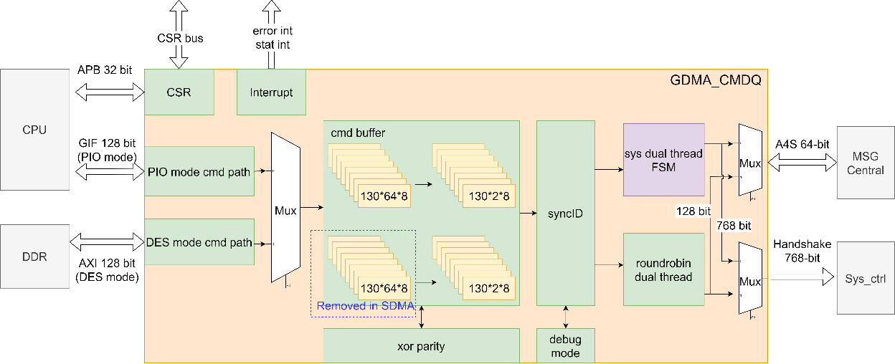
图5-2 DES内部架构图

- DES模块负责GDMA的指令接收和分发，有两种方式可以接收指令：CMDQ mode和PIO mode。CMDQ mode透过axi master端口向DRAM取得指令，PIO mode是CPU透过axi slave端口配置指令。
- DES模块内部CSR同样由axi slave端口配置和读取。Axi slave端口还可读取正在执行的descriptor。Axi slave的address bank分配见下表。

 | start address[15:0] | End address[15:0] | space
GDMA | 0x0000 | 0x07ff | master thread des
 | 0x0800 | 0x0fff | slave thread des
 | 0x1000 | 0x13ff | CSR
 | 0x1400 | 0x17ff | RDMA
 | 0x1800 | 0x1bff | WDMA
表5-1 Axi slave接口address bank分配。

- Descriptor chain由一串descriptor构成，系统沟通指令（SYS指令）长度为128 bit，数据搬运指令为768 bits；DES模块内部直接执行SYS指令，非SYS指令分发到datapath中执行。
- DES模块支持GDMA和TPU之间通过sync_id机制同步，如图5.2.1.2，ST3执行需等待Conv1结束，Conv1的执行需等待LD2结束。
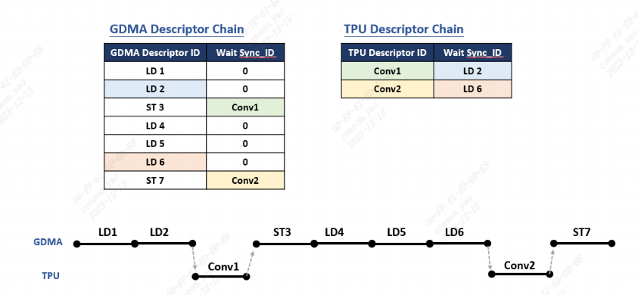
图5-3 descriptor chain

- CMDQ mode取指令时，burst length固定为8，每笔request满足地址128B对齐，数据位宽为128 bit，即每个burst为1024 bits，outstanding能力为8，读取到sys_end指令后，停止读请求，并抛弃所有后续数据，如图5.2.1.3。
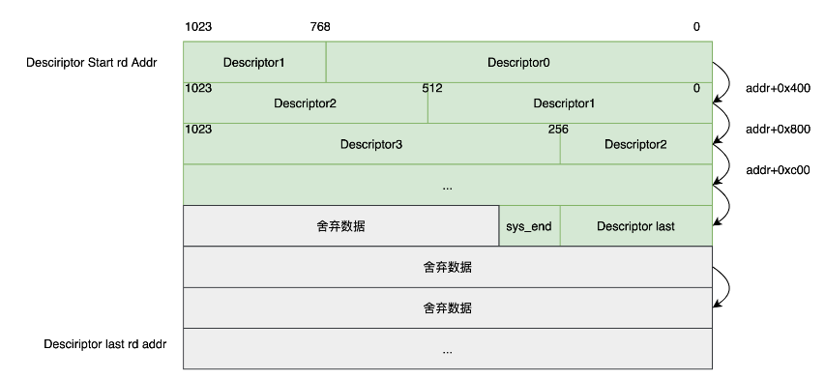
图5-4 指令组合方式

- DES模块透过A4S端口与MSG central沟通同步，该过程通过SYS指令中send和wait完成。
- Xor校验计算指令中每64bit的偶校验结果，与指令一同存放于指令buffer中，用于检验指令在buffer中是否发生奇数个bit错误。
- Debug mode支持单步模式（single step mode）和断点模式（breakpoint mode），单步模式时，GDMA每执行一条指令会停止，断点模式会在descriptor[87]位段识别到断点后停止，软体配置dbg_exec_enable信号或退出dbg mode才可再次执行指令。
- DES模块在GDMA中只有单线程，在SDMA中有双线程，两条线程指令分发和与MSG central沟通均通过roundrobin仲裁进行。
- 指令从buffer中读出后，先进行同步机制判断，通过后判断指令类型，分发非SYS指令或SYS指令，每条指令结束后更新cmd_id，具体时序如图5.2.1.4。
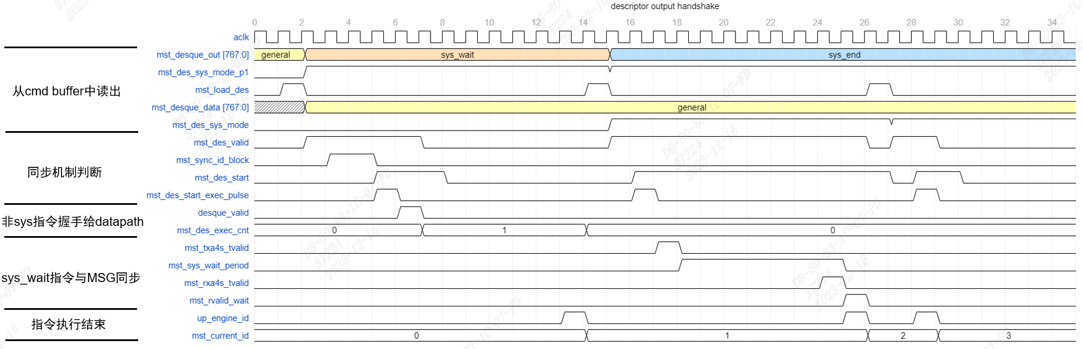
图5-5指令分发和执行

Gdma_sys_ctrl Module
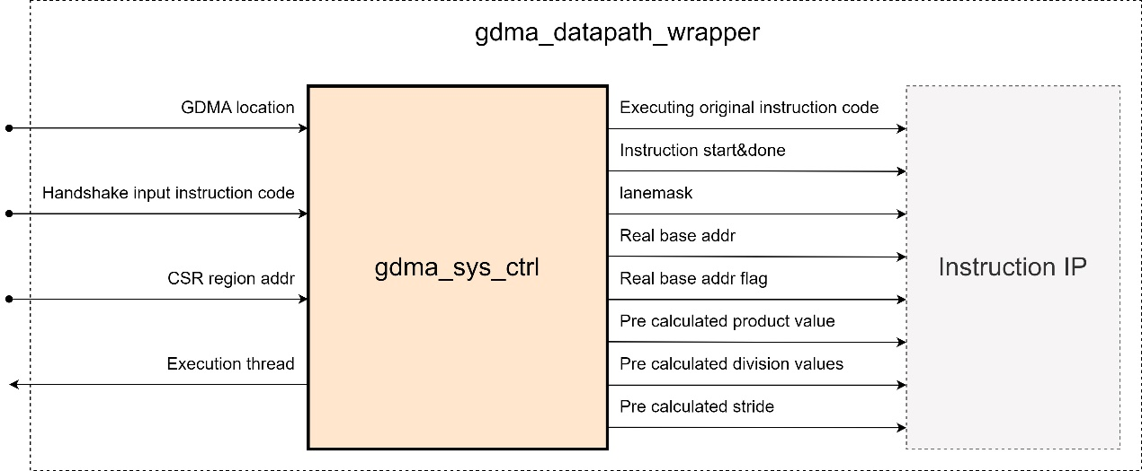
图5-6 gdma_sys_ctrl block diagram

gdma_sys_ctrl 为 gdma_datapath_wrap 中各指令的中央控制单元。gdma_sys_ctrl 与 DES_module握手得到需要搬运数据指令的 768bits 指令码，对指令码进行初步解译后，触发要执行的指令单元，并把经过初步处理的信息传给指令单元。(图3.2.2 中 Istruction IP block 为 GMDA 支持指令的抽象集合)
gdmasys_ctrl 支持如下 feature
- 支持预计算指令需要的stride/乘积/除法信息
- 支持计算指令的起始地址，并判断地址是否处于 TPU 内的 smem/lmem，并将判断信息传给指令
- 支持 pipe 处理预计算信息，当当前指令处于执行阶段时，可预计算下条待执行指令的乘法与除法
- 支持执行执行阶段保持指令执行信息

matrix Module
matrix分成normal mode和transpose mode，transpose mode对tensor进行转置。
matrix可以从GMEM/L2M搬运到LMEM，或者是从LMEM搬运到GMEM/L2M。
其指令描述如下。
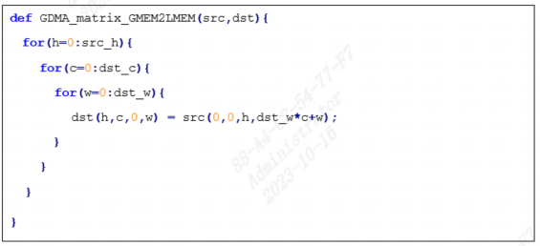
其整体架构如下
图5-7 matrix block diagram
外部的share matrix是两组128x128byte的sram，与transpose指令共用。当需要转置时，外部的rdma每次以128x128byte为单位取数到share matrix进行转置，然后再从share matrix读取数据写到wdma。matrix有normal mode和transpose mode。transpose mode需要进行转置。
rdma_ctrl基于128x128byte block从LMEM/GMEM/L2M取数，然后送到matrix_core，matrix_core再生成sram的读写时序，外部的sram主要进行transpose转置功能，实现128x128byte矩阵的转置，再送回到matrix core，matrix core再将数据输出到wdma_ctrl，wdma_ctrl再写到LMEM/GMEM/L2M。
normal mode在LMEM的存储示意图示意图如下
图5-8 normal mode在LMEM的存储示意图

transpose mode的示意图如下 (GMEM to LMEM)
图5-9 transpose mode在LMEM的存储示意图

matrix 有如下 feature
- src/dst memory 支持 DDR/L2M/LMEM。只能从DDR/L2M取数到LMEM，或者是LMEM取数到DDR/L2M。
- 支持normal mode和transpose mode两种模式。
- src 与 dst 数据单元 size 相等，数据单元 size 支持 8bit/16bit/32bit
- 当 src c_stride 128byte 对齐时，支持发给 rdma 的每笔 request 都不跨 128byte 边界
- 当 dst c_stride 128byte 对齐时，支持发给 wdma 的每笔 request 都不跨 128byte 边界
- 支持 rdma axi 端最大 outstanding 128笔 request

cw_transpose Module
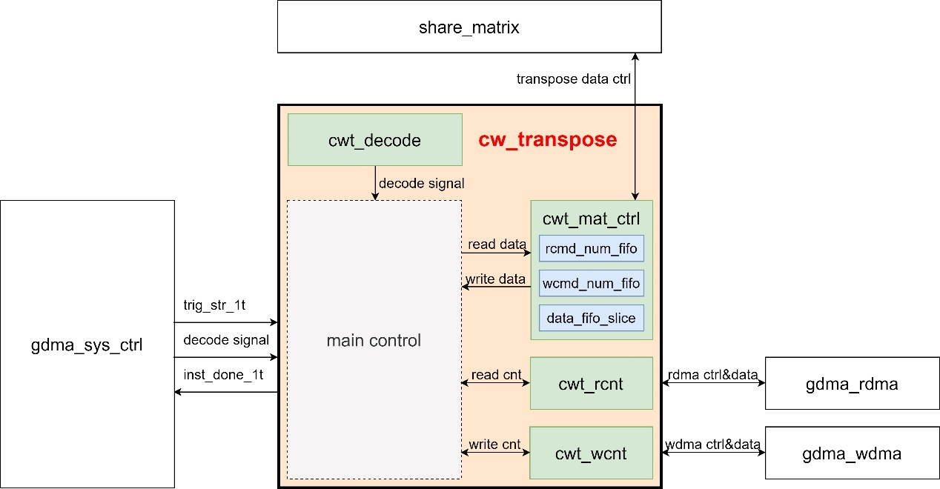
图5-10 cw_transpose 结构图 (橙色区域)

如图 橙色区域所示，为 cw_transpose 的结构图。cw_tanspose 从 gdma_sys_ctrl 接收指令信息，将 src 数据块按 c、w 维度进行分拆，将分拆的数据块交由 share_matrix 进行转置，转置后写到 dst 端。
cw_transpose 指令 IP 包括 cwt_decode / cwt_mat_ctrl / cwt_rcnt / cwt_wcnt 模块。main control 为抽象的主控制部分。
cwt_decode : 将 gdma_sys_ctrl 的信息作进一步 decode
cwt_mat_ctrl : 对数据作转置的控制，将读取的数据发送给 share_matrix 进行转置。其中包括两个 1x256bits 寄存器 FIFO 与一个 1024x2bits 寄存器 FIFO
cwt_rcnt : 分 n/c/h/w 维度对读取数据进行计数，并产生控制信号标志
cwt_rcnt : 分 n/c/h/w 维度对写出数据进行计数，并产生控制信号标志
cw_transpose 有如下 feature
- src/dst memory 支持 ddr/l2m/lmem
- 支持 src w/c 维度分别与 dst c/w 维度相等，其它维度保持不变
- src 与 dst 数据单元 size 相等，数据单元 size 支持 8bit/16bit/32bit
- 支持 nchw_copy 模式，当工作在 nchw_copy 模式时，无需配置 dst 维度信息，dst n/c/h/w 维度分别等于 src n/w/h/c 维度
- 当 src c_stride 128byte 对齐时，支持发给 rdma 的每笔 request 都不跨 128byte 边界
- 当 dst c_stride 128byte 对齐时，支持发给 wdma 的每笔 request 都不跨 128byte 边界
- 与 rdma 共同工作，支持 rdma axi 端最大 outstanding 128笔 request

lossless compress Module
- 压缩前是tensor[n,c,h,w]，压缩后是map_vlc_tensor[n, lane_c, h, gcw]，header的tensor META_tensor(n,lane_c,h,4). 即gcw=gc*w,gc=64(以下图而言,最后一个是16),即NPN_NUM.
- map_vlc_tensor按未压缩的最大内存去开，只省了带宽，没有省内存。
- 当lc为0时，先取出h=0的lane0~lane63，作为一个整体拼凑起来进行压缩。h依次递增。racu_compress压缩流程如下图所示
图5-11 racu_compress压缩流程图

- compress前，会先从LMEM lanes gatther一行进行压缩。即compress前先执行gatther。
- decompress后，会把压缩结果scatter到LMEM的各条lanes上。即decompress后会执行scatter。
compress的大致算法流程如下图所示
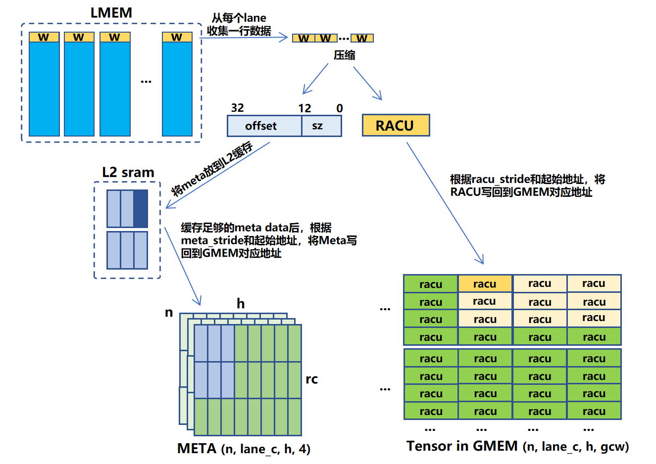
图5-12 racu_compresss算法流程图

每16个数据单元(8bit或16bit)输入到一个tpu_ve压缩核，压缩后得到一个map和vlc。每个map 8bit或16bit。每个vlc的有效数据宽度未定，最大位宽为未压缩的原始数据，即128bit/256bit。每个racu_h压缩后得到一个header，每个header 32bit。racu compress将header按32bit format存储到meta address。map和vlc紧凑存储到racu_address。
以racu_h=256为例，header在GMEM/L2M的存储如下图所示。
图5-13 header在GMEM/L2M的存储格式

map+vlc在GMEM/L2M的存储格式如下图所示
图5-14 map+vlc在GMEM/L2M的存储格式

gdma_compress整体架构如下:
图5-15 lossless compress架构图

rdma ctrl从LMEM取数，先缓冲到128x128byte的sram，然后输入到gdma_compress_core，gdma_compress_core将16个data拼成一个待压缩数据单元。如上图所示，8bit模式每128bit为一个待压缩数据单元，16bit模式每256bit为一个待压缩单元。然后待压缩数据统一移位成128bit的数据，输入到tpu_ve_0~tpu_ve_7进行编码。编码后的vlc/map/header，再各自pad成1024bit数据，存放到外部的fifo，然后再输出到wdma_ctrl，wdma_ctrl产生vlc/map/header各自的写地址和写数据，发送到GMEM/L2M。
compress 有如下 feature
- src memory 支持 LMEM。dst memory 支持GMEM/L2M。
- 支持racu mode和normal mode两种压缩模式。
- src 与 dst 数据单元 size 相等，数据单元 size 支持 8bit/16bit
- 当 src c_stride 128byte 对齐时，支持发给 rdma 的每笔 request 都不跨 128byte 边界
- 当 dst c_stride 128byte 对齐时，支持发给 wdma 的每笔 request 都不跨 128byte 边界
- 与 rdma 共同工作，支持 rdma axi 端最大 outstanding 128笔 request

lossless decompress Module
- 先通过meta(header)的起始地址，从DDR/L2M取出要解码的header，通过vlc的起始地址和从header提取出来的对应offset，从DDR/L2M取出racu编码码流和对应的map数据送到解码核进行解码，解码完写到TPU的LMEM。其算法示意图如下
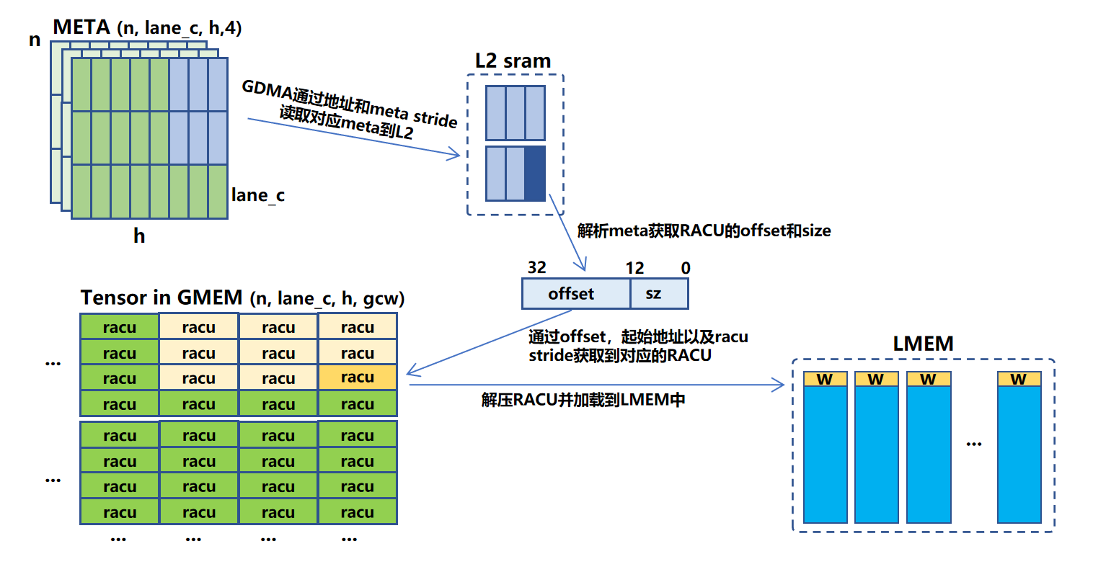
图5-16 lossless decompress算法示意图
gdma_decompress的框架图如下所示
图5-17 lossless decompress架构图
rdma ctrl先根据meta_addr从GMEM/L2M取header，从header解析offset，再结合编码码流的起始地址racu_addr，得到待解码的racu编码块的起始地址取map和vlc。map首先解析每个编码数据的大小，表征为map_len0~map_len7，vlc_i根据map_len0~map_len7进行移位得到每个待解码的数据，再送到tpu_vd_0~tpu_vd_7进行解码，解码后的数据拼凑成1024bit数据，输出到wdma_ctrl，写到对应的LMEM地址。
decompress 有如下 feature
- src memory 支持 GMEM/L2M。dst memory 支持LMEM。
- 支持racu mode和normal mode两种解压缩模式。
- src 与 dst 数据单元 size 相等，数据单元 size 支持 8bit/16bit
- 当 src c_stride 128byte 对齐时，支持发给 rdma 的每笔 request 都不跨 128byte 边界
- 当 dst c_stride 128byte 对齐时，支持发给 wdma 的每笔 request 都不跨 128byte 边界
- 与 rdma 共同工作，支持vlc/map/header的rdma outstanding num可配，总和128笔outstanding request。
- rdma支持vlc/map/header的requst 优先级可配，默认优先级vlc>map>header。

lossy compress Module
lossy compress将fp32截取掉低位的12bit转换成fp20格式。lossy compress支持从LMEM搬运到GMEM/L2M，也支持从GMEM/L2M搬运到GMEM/L2M。lossy compress会将整个tensor首尾相接pad到一起进行压缩。其指令示意图如下
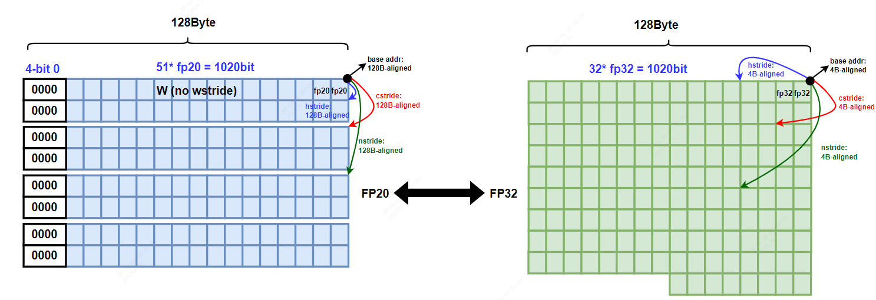
图5-18 lossy compress指令示意图

如上图所示每1020bit的fp20会高位填充4bit的无效bit，然后pad成1024bit。
lossy_compress的架构图如下所示
图5-19 lossy compress架构图

rdma ctrl先从GMEM/L2M/LMEM取出原数据输出到gdma_lossy_compress_core。每个数据单元32bit即fp32,取fp32的高20bit，每个1024bit数据取出对应的640bit有效数据进行拼凑，每拼成1020bit有效数据，就高位填充4bit 0拼成1024bit，然后输出到wdma_ctrl写到GMEM/L2M。
lossy_compress 有如下 feature
- src memory 支持 GMEM/LMEM或LMEM。dst memory 支持GMEM/L2M。只能GMEM/L2M取数到GMEM/L2M或是LMEM取数到GMEM/L2M。
- 整个tensor按照whcn的顺序首尾拼凑进行压缩。
- src 的data format是fp32，dst的data format是fp20
- 当 src c_stride 128byte 对齐时，支持发给 rdma 的每笔 request 都不跨 128byte 边界
- 当 dst c_stride 128byte 对齐时，支持发给 wdma 的每笔 request 都不跨 128byte 边界
- 与 rdma 共同工作，支持rdma的outstanding num 128笔request。

lossy decompress Module
lossy decompress是lossy compress的逆过程，从DDR/L2M将fp20低位填充12bit的0，然后pad成fp32，再输出到DDR/L2M/LMEM。其算法示意图如下

图5-20 lossy decompress指令示意图

gdma_lossy_decompress的示意图如下
图5-21 lossy decompres架构图

rdma ctrl先从GMEM/L2M取出原数据输出到gdma_lossy_decompress_core，每个数据单元20bit，即fp20，低位填充12bit 0成fp32。每640bit数据填充成1024bit有效数据，然后输出到wdma_ctrl写到LMEM/GMEM/L2M。
decompress 有如下 feature
- src memory 支持 GMEM/L2M。dst memory 支持GMEM/L2M或LMEM。只能GMEM/L2M取数到LMEM或GMEM/L2M取数到GMEM/L2M。
- src 的data format是fp20，dst的data format是fp32
- 当 src c_stride 128byte 对齐时，支持发给 rdma 的每笔 request 都不跨 128byte 边界
- 当 dst c_stride 128byte 对齐时，支持发给 wdma 的每笔 request 都不跨 128byte 边界
与 rdma 共同工作，支持rdma的outstanding num 128笔request。

gather_ scatter Module
gather_scatter指令用于在DRAM、L2M、LMEM、SMEM之间按照角标精确地搬运tensor数据。
- 支持gather、scatter_inplace、scatter_sum模式
- 支持常数填充
- 支持数据格式：8bit、16bit、32bit，scatter_sum模式仅支持fp16、bf16、fp32、int8、int16、int32
- 仅h、c维度支持stride
- 理论带宽：128Byte/cycle
- 支持lane mask
图5-22 gather_scatter uArch
在gather和scatter_inplace模式下，idx control ip发出读idx的req，将读回的idx data依序bypass掉idx fifo送进data control，data contrl ip根据收到的idx发出读src与写dst的req，将读回的src data写出至dst。
在scatter_sum模式下，idx control ip发出读idx的req，将读回的idx data依序送进idx fifo，等到之前发出的由相同idx生成的wreq的wresp回来之后，再将idx data送进data control，data control ip根据收到的idx发出读src、读dst与写dst的req，将读回的src data和读回的dst data相加之后写出至dst。

general_reverse Module
General指令将数据在DRAM、L2MEM、LMEM、SMEM之间按照1维数组的方式进行搬运。其支持：
1. 支持常数填充(fill const)，也就是用值为const_val的常数覆盖length长度的存储空间；
2. 支持对LMEM中lane之间的广播，将需要发送的数据写到不同lane上的同一偏移地址；
3. 支持以下数据类型：8 bit/16 bit/32 bit

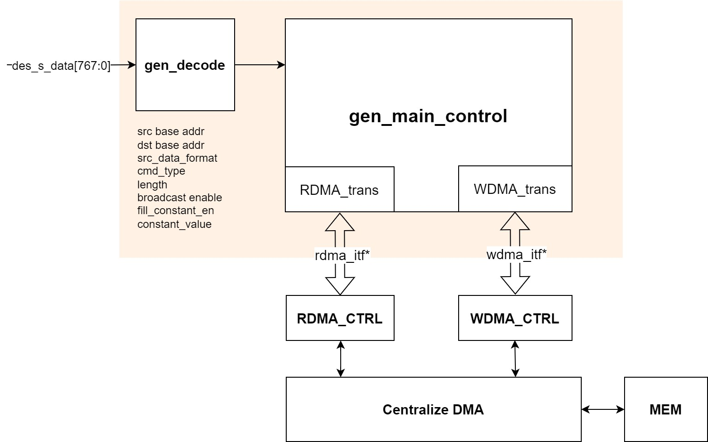
圖5-23 general block module

General指令根据参数配置不同主要分三种模式，分别是normal，常数填充(fill_const)和广播(broadcast)模式，其中broadcast能和normal、fill_const模式同时开启。Normal模式下，general指令首先接收到该指令的trig_str_1t信号，gen_decode模块根据输入的768bit配置信息des_s_data解码出src addr，dst addr，data length等信息，计算出该笔req的data byte数，gen_main_ctrl模块向rdma ctrl发出读请求r_req，并包括seglen，src addr等信息，向wdma ctrl发出写请求w_req，包括seglen，dst addr等信息，传输完成后，拉起ip_inst_done_1t信号，表示完成一次general指令的数据传输，一次general指令中至多只会发出一次r_req和w_req。Fill const模式下，general不发出读请求，仅发出写请求，根据gen_decode解析的const value和length在内部写出对应长度的常数值； broadcast仅在LMEM中进行，在该模式下，gen_main_ctrl模块向wdma ctrl发出的dst 地址中会包含LMEM起始lane id的信息。
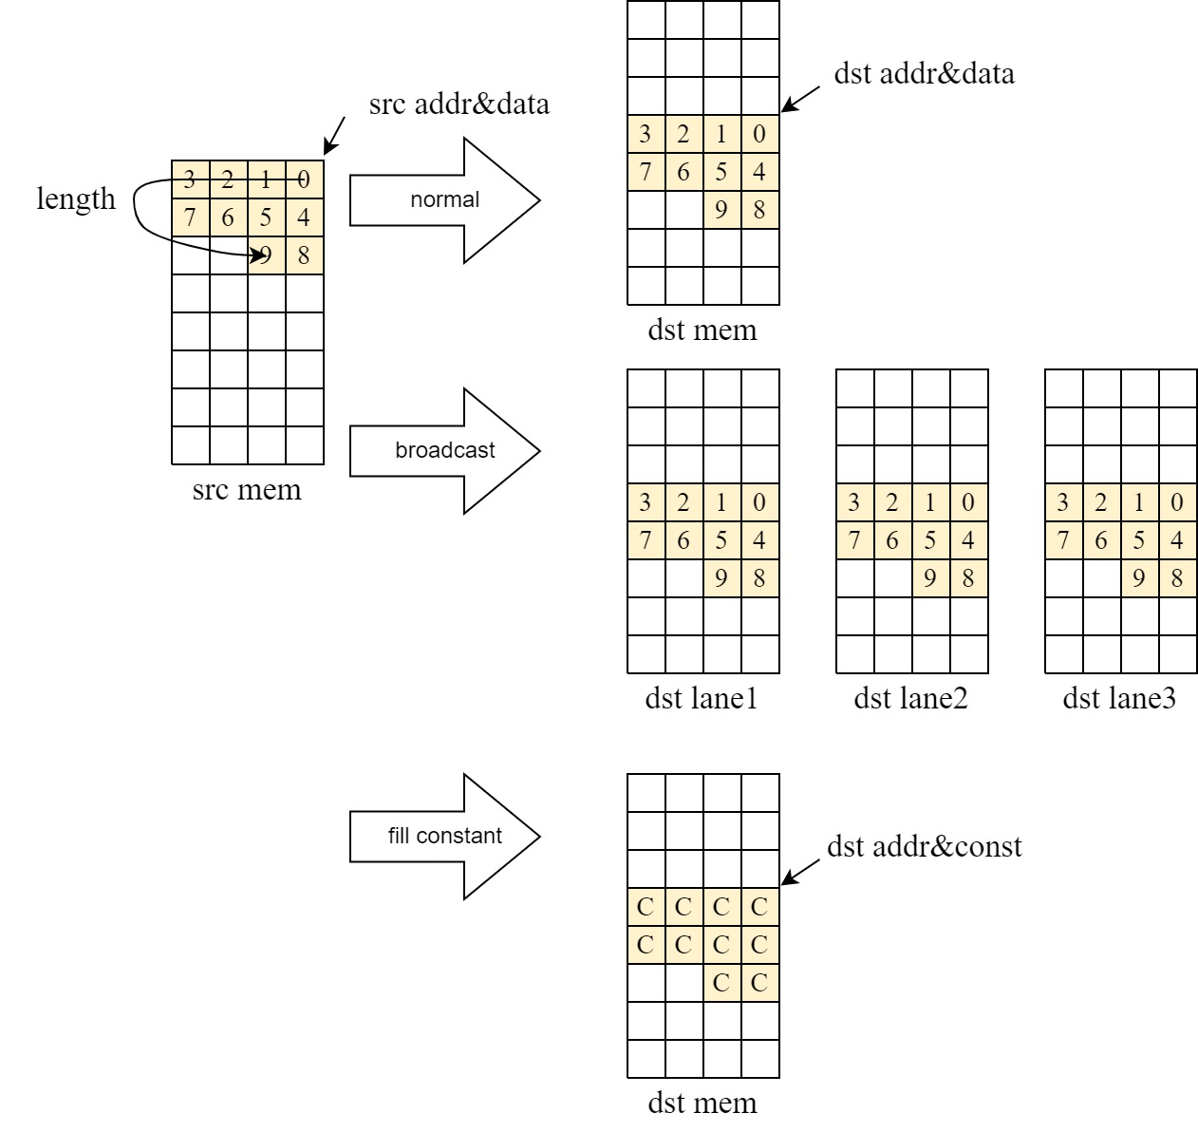
圖5-24 general 指令示意图

Reverse指令是将tensor形状的数据在指定维度(n/c/h/w)上进行反转存放，反转前后各维度的尺寸大小保持不变。其支持：
1. 在src mem为LMEM时只支持C维反转；
2. 在src mem非LMEM时支持N/C/H/W四个维度的反转，一次指令中仅支持单一维度反转；
3. 支持src/dst mem：GMEM/L2M/LMEM/SMEM；
4. 支持数据类型：8 bit/16 bit/32 bit
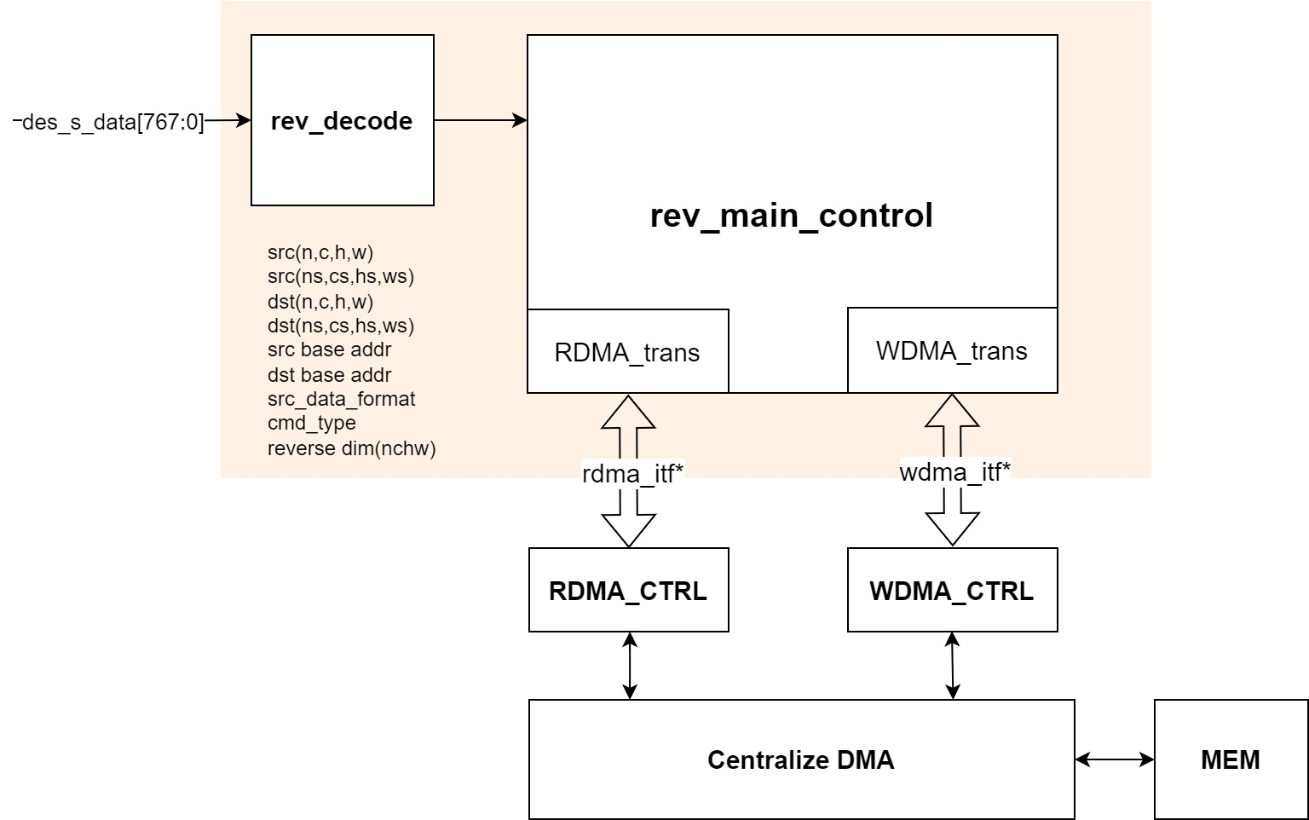
圖5-25 reverse block module
Reverse指令接收到该指令的trig_str_1t信号，rev_decode模块根据768bit的配置数据des_s_data解码出src、dst addr，size，stride，reverse dim等信息，rev_main_ctrl向rdma ctrl发出读req，包括seglen，src addr等信息，向wdma ctrl发出写req，包括seglen，dst addr等信息。在进行N、C、H维度的反转时，仅在地址上进行反转操作，即对应维度的第x个data会在(size – x)的地址上写出wdma；在W维度的reverse时，每笔128Byte的data会在内部先根据当前data size按8/16/32bit进行反转，再写出wdma，传输全部完成后，ip会拉起ip_inst_done_1t信号，表示完成一次reverse指令的数据传输。
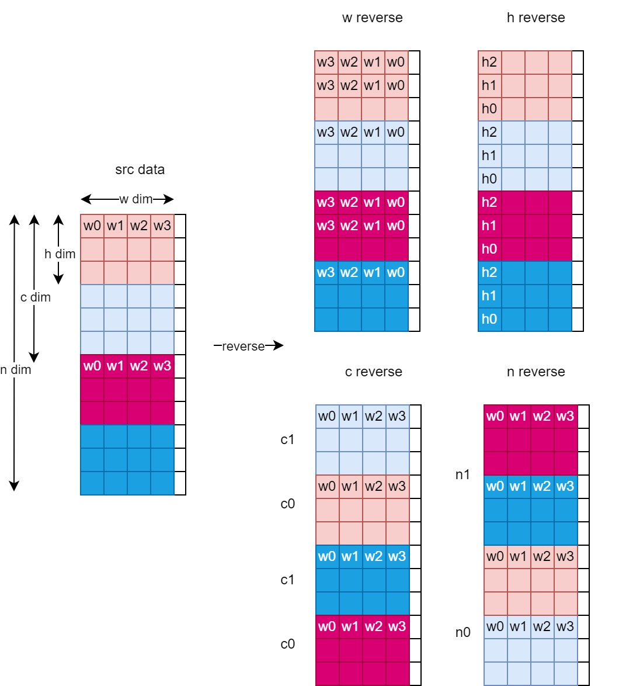
圖5-26 reverse指令示意图

maskselect_nonzero Module
图5-27 maskselect内部模块图
Mask_select指令按照mask有选择性地对数据进行搬移，支持：
- src/mask支持GMEM/L2M/LMEM，dst仅支持GMEM/L2M，src，mask和dst三者之间可支持相同或不同mem；src，mask均为tensor格式，不支持lane mask ；
- mask和src在LMEM中要求对齐存储，在GMEM/L2M中要求紧密存储；dst必须紧密存储；
- Src支持8bit/16bit/32bit，dst src数据格式相同;
- 若tensor的h或w维size大于16bit，则可将tensor的shape看成(n, c, 1, w’),其中w’=h*w.并设置指令cmd_special_function字段为ncw mode, 并将指令中的src_h和dst_h设置为w’的高16位，src_w和dst_w设置为w’的低16位
图5-28 nonzero内部模块图
nonzero该指令的功能是输出src中为不为0的元素的index，支持：
- Src支持8bit/16bit/32bit的整数和浮点格式，index仅支持uint8，uint16和uint32，src和index可为不同数据格式. Src tensor数据量应在index_data_format能表示的范围内，例如int8仅能表示0～255.
- src支持LMEM/GMEM/L2M，dst仅支持GMEM/L2M，支持来自相同或不同的memory.
- src在LMEM中要求对齐存储，在GMEM/L2M要求紧密存储；src/dst hw必须紧密存储，stride由硬件生成不需要软件配置.
- src/dst tensor尺寸要求相同

tensor Module
tensor指令用于在DRAM、L2M、LMEM、SMEM之间高效率地搬运tensor数据。
- 支持模式：normal、broadcast、nc-transpose
- 支持fill-constant
- 支持tensor形状重排
- 支持数据格式：8bit、16bit、32bit、20bit(normal mode)
- 各维度均支持stride
- 支持h连续(hstride – wsize < 128Bytes)
- 支持c连续(cstride – hstride*hsize < 128Bytes)
- 支持n连续(nstride – cstride*csize < 128Bytes)
- 理论带宽：128Bytes/cycle(with no wstride)\32Bytes/cycle(with wstride)
- 支持跨lane连续
- 支持ARE (All Reduce Engine)
- 支持lane mask
- 支持软件设置写无bubble wstrb模式
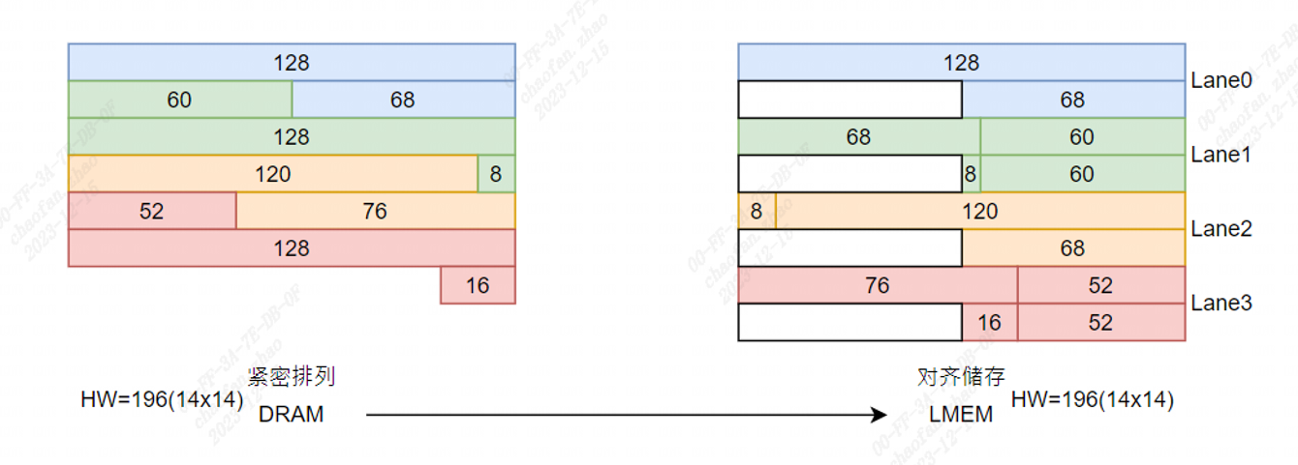
图5-29 tensor跨lane连续
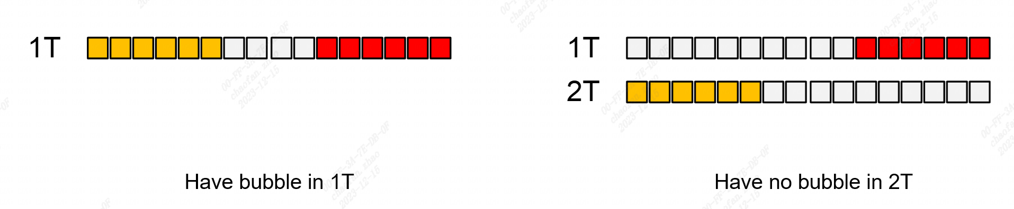
图5-30 支持写出无bubble wstrb模式
tensor指令有三种工作模式：normal mode、lane-across mode、wstride mode。
图5-31 normal mode
Normal mode下，读写指令由Req_Gen ip生成；数据bypass掉src_wstride_squeeze ip和input byte fifo，直接进入1T128B core，之后数据bypass掉output byte fifo和dst wstride insert ip直接写出。
图5-32 lane-across mode
Lane-across mode下，读写指令由Req_Gen ip生成；数据bypass掉src_wstride_squeeze ip，直接进入input byte fifo，之后数据bypass掉1T128B core直接进入output byte fifo，读出需要的数据长度之后直接写出。
图5-33 wstride mode
Lane-across mode下，读写指令由Req_Gen ip生成；数据进入src_wstride_squeeze ip挤出wstride，进入input byte fifo，之后数据进入1T128B core，进入output byte fifo，读出需要的数据长度之后进入dst_wstride_insert ip插入wstride，之后写出。

RDMA Module
图5-34 rdma内部架构图
rdma的主要作用是将来自指令IP的dma request拆分为axi request,并将通过axi读回的数据返回给指令IP
rdma有如下feature
- support 1024 bit data bus for GDMA, 512bit for CDMA
- support DMA outstanding request(for gdma instruction module request) max outstanding num 16
- DMA outstanding 的方式，不同的instruction之间发出的DMA不会outstanding
- AXI最大outstanding 128
- support byte mode
- Support parameterize maximum burst length ( configure to 2) max AxLEN=1 for GDMA, maximum burst length ( configure to 4 ) max AxLEN=3 for CDMA
- support RDMA 保序(out of order + interleave)
- support RDMA 128 byte align
- broadcast cmd 包含在address中，dma不需要处理, address中额外加上1bit control info
- BW limit
- DMA abort(central dma内部电路tie0不生效，使用gdma top加上stopper的方式取代)
- 256 byte 边界for GDMA, 512/256 byte for CDMA(base on burst size)
- 3个client相互独立，instruction可以选择使用任意数量的dma
- 支持1024 to 512 bit data bus转换(for CDMA)
- 支持外部使用slot mem(for CDMA, 将sram 接口引入给指令集ip)
- rdma client0 support cache(remove for area duction in sg2260 gdma)

WDMA Module
图5-35 wdma内部架构图
wdma的主要作用是将来自指令IP的dma request拆分为axi request,并将来自指令IP的数据通过axi写出去
wdma有如下feature
- support 1024 bit data bus for GDMA, 512bit for CDMA
- support 1024 bit data bus for GDMA, 512bit for CDMA
- support DMA outstanding request(for gdma instruction module request) max outstanding num 16
- DMA outstanding 的方式，不同的instruction之间发出的DMA不会outstanding
- AXI最大outstanding 128
- support byte mode
- Support parameterize maximum burst length ( configure to 2) max AxLEN=1 for GDMA, maximum burst length ( configure to 4) max AxLEN=3 for CDMA
- WDMA支持通过wstrb方式进行非128byte对齐write请求
- WDMA的AW_ID也要需要随着outstanding的变化而变化
- wstrb之间有间隔(由special mode 选择)
- broadcast cmd 包含在address中，dma不需要处理, address中额外加上1bit control info
- BW limit
- DMA abort(central dma内部电路tie0不生效，使用gdma top加上stopper的方式取代)
- 256 byte 边界for GDMA, 512/256 byte for CDMA(base on burst size)
- AW_ALL_DONE(最后一笔dma的最后一个aw_done)
- WDMA支持early response(IP端需提供最后一笔dma request信号)
- WDMA 可以处理seglen不准确的dma request(需要真实的strb, 由special mode 控制)
- 3个client相互独立，instruction可以选择使用任意数量的dma
- 支持1024 to 512 bit data bus转换(for CDMA)
- 支持外部使用slot mem(for CDMA, 将sram 接口引入给指令集ip)

GIF/DTN interface Module
图5-36 GIF and DTN interface diagram
该模块用于将来自Centralize DMA的axi接口转换成gif接口和dtn接口。主要包含以下几个部分：
- axi_1to2_fab:该模块用于将一组axi接口转换成两组axi接口。通过输入的AXADDR最高位来进行选择。
- DTN的映像地址为：41’h000_0000_0000~41’h0ff_ffff_ffff;
- GIF的映像地址为：41’h100_0000_0000~41’h1ff_ffff_ffff；
- axi_to_dtn:该模块用于将axi协议转换成dtn协议，从而实现数据的高速传输，且该协议以Packet的形式传输数据，更契合数据在 NoC 中的流动。
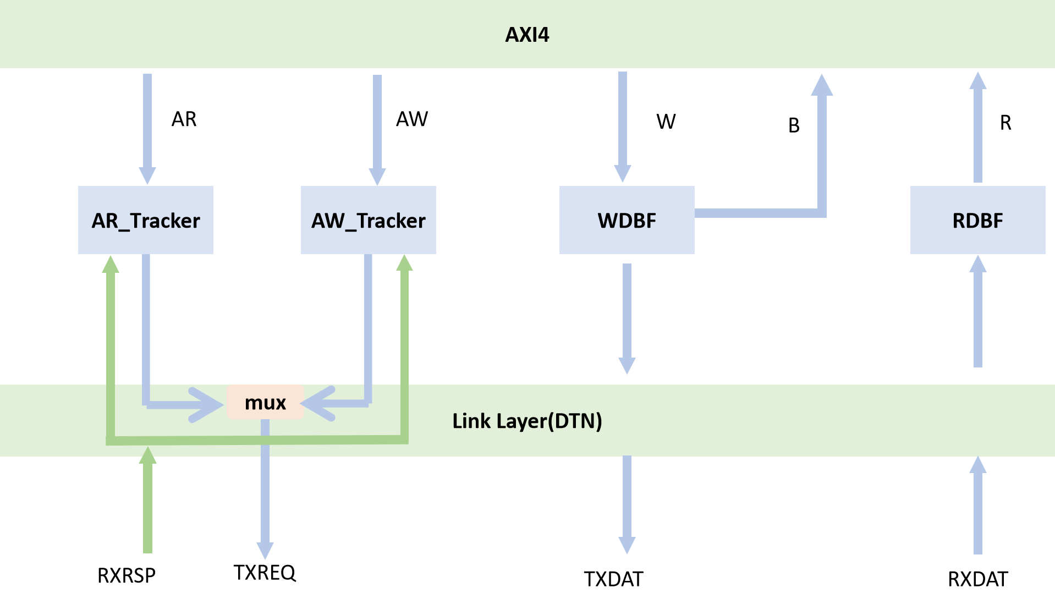
图5-37 axi to dtn 架构图
- axi_to_gif:该模块用于将axi协议转换成gif协议，从而简化了连接。GIF由两个独立的请求和响应通道组成，每个通道都是从单个源到单个接收器的点对点连接。这些通道提供了双向流控制，类似于在AXI总线上的握手。
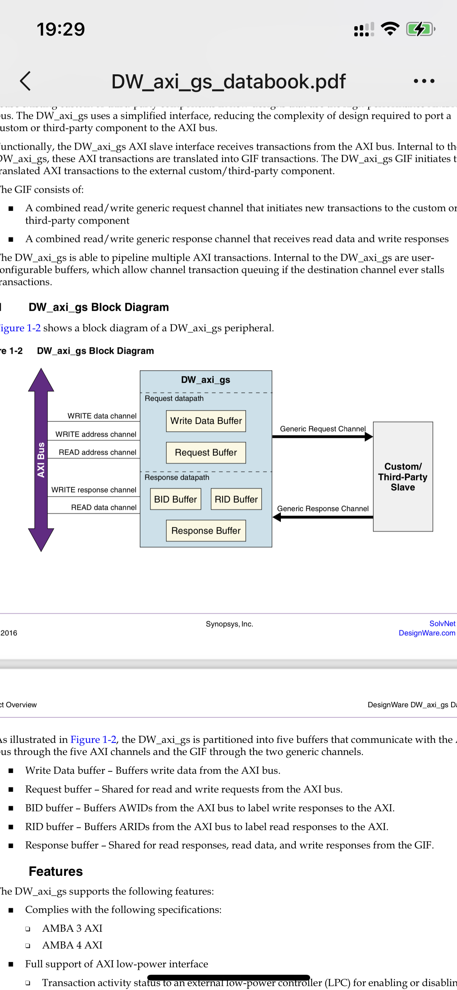
图5-38 axi_to_gif Block Diagram
- PMU: performance monitor unit是检查GDMA在一定时间内的传输效率情况。经过一段时间后，PMU可以通过AXI AW/W通道发送结果，该通道属于GDMA的des主端口；
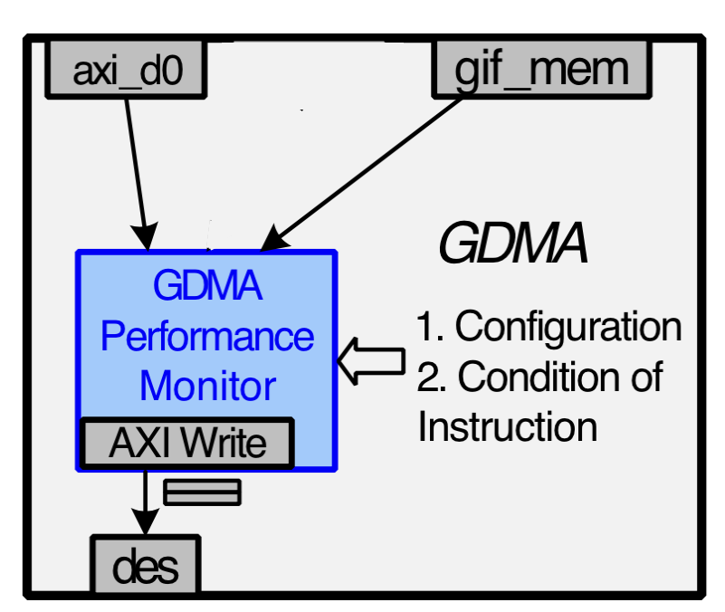
图5-39 PMU 架构图

Register description
以下为axi_slave端口可访问的寄存器模块，更详细信息见：
https://wiki.sophgo.com/pages/viewpage.action?pageId=96449056
The following subsections describe the data fields of gdma_csr registers.
gdma_csr_0
Offset Address: 0x000
Bits | Name | Access | Description | Reset
0 | des_mode_enable | RWS | 0: gdma in PIO mode  1: gdma in DES mode  A2:WSC -> 2260:rws
1 | sync_id_reset | W1P | 0: Do not reset the SyncID output  1: Reset the SyncID output to be all 0s  This bit will be cleared immediately after write.  A2:WSC -> 2260:w1p
2 | slv_des_mode_enable | RWS | when thrd_mode is 0, this bit is equivalent to des_mode_enable, sw needs to write 1 to start fetching cmd for slave thread
3 | low_power_enable | R/W | 0:disable clk gate  1:enable clk gate | 0x0
4 | des_clr | RWS | 清空指令buffer  写1‘b1 使能  自动清0
5 | gif_bpn | R/W | 为0时控制gif可反压，为1时gif不可反压 | 0x0
6 | cache_cg_en | R/W | 为1时 clk_gate tie1，为0时 clk_gate 根据指令控制 | 0x0
7 | slv_sync_id_reset | W1P | when thrd_mode = 0, this bit is used to set slave thread cmd_id to 32'h0  0: Do not reset the SyncID output  1: Reset the SyncID output to be all 0s  This bit will be cleared immediately after write.  A2:WSC -> 2260:w1p
14:8 | mst_ins_buf_status | RO | master thread, Current entry number of the Ins Buf. It means how many descriptors that SW can write to Ins Buf.  If the Ins Buf is full, this field will be 0.
15 | thrd_mode | R/W | sw set the dual thread mode. 0: sdma dual thread roundrobin; 1: gdma dual thread fork/join/exit | 0x0
24:16 | message_base_id | R/W | message_id use for snyc_wait and sync_send | 0x0
31:25 | slv_ins_buf_status | RO | slave thread, Current entry number of the Ins Buf. It means how many descriptors that SW can write to Ins Buf.  If the Ins Buf is full, this field will be 0.
gdma_csr_1
Offset Address: 0x004
Bits | Name | Access | Description | Reset
31:0 | master_des_addr_l32 | R/W | If the Ins Buf is full, this field will be 0. | 0x0
gdma_csr_2
Offset Address: 0x008
Bits | Name | Access | Description | Reset
0 | master_des_addr_h1 | R/W | Master descriptor Address Pointer [39] is updated by this register’s bit. | 0x0
31:1 | Reserved
gdma_csr_3
Offset Address: 0x00c
Bits | Name | Access | Description | Reset
31:0 | slave_des_addr_l32 | R/W | Slave descriptor Address Pointer [38:7] is updated by this register’s bit.  Slave descriptor address’s bit [6:0] are always 0.  both SW and HW can write: add an ro type register for apb read path | 0x0
gdma_csr_4
Offset Address: 0x010
Bits | Name | Access | Description | Reset
0 | slave_des_addr_h1 | R/W | Slave descriptor Address Pointer [39] is updated by this register’s bit. | 0x0
31:1 | Reserved
gdma_csr_5
Offset Address: 0x014
Bits | Name | Access | Description | Reset
31:0 | perf_monitor_res_start_addr_l32 | R/W | the ddr start address [38:7] for performance monitor is update by this register's bit[31:0].bit[0]must be 0  the bit [6:0] is always 0. | 0x0
gdma_csr_6
Offset Address: 0x018
Bits | Name | Access | Description | Reset
0 | perf_monitor_res_start_addr_h1 | R/W | the ddr start address [39] for performance monitor is update by this register's bit[0]. | 0x0
31:1 | Reserved
gdma_csr_7
Offset Address: 0x01c
Bits | Name | Access | Description | Reset
31:0 | perf_monitor_res_end_addr_l32 | R/W | the ddr end address [38:7] for performance monitor is update by this register's bit[31:0].bit[0] must be 0  the bit [6:0] is always 0. | 0x0
gdma_csr_8
Offset Address: 0x020
Bits | Name | Access | Description | Reset
0 | perf_monitor_res_end_addr_h1 | R/W | the ddr end address [39] for performance monitor is update by this register's bit[0]. | 0x0
31:1 | Reserved
gdma_csr_9
Offset Address: 0x024
Bits | Name | Access | Description | Reset
31:0 | mst_current_sync_id | RO | Current SyncID output of this engine. This field will automatically update to be consistent with the SyncID output of this engine for master thread.
gdma_csr_10
Offset Address: 0x028
Bits | Name | Access | Description | Reset
31:0 | word_nums_after_filter | RWC | used in DMA_masked_select/DMA_nonzero command, this means the number of the data after filtering .  A2:WTC(address decoded clear) -> 2260:rwc(write 1 to clear)
gdma_csr_11
Offset Address: 0x02c
Bits | Name | Access | Description | Reset
0 | mem_size_per_npu | RO | For NCHW data, based on MEM size of a NPU, it can know the start address of next NPU  0: 128KB  1: 256KB
1 | eu_num_per_npu | RO | EU_NUM in each NPU (operate on int8)  0: 128;
2 | npu_num | RO | NPU NUMBER  0: 64;  1: 32；
31:3 | Reserved
gdma_csr_12
Offset Address: 0x030
Bits | Name | Access | Description | Reset
0 | intr_status_disable | R/W | Interrupt Disable,highest priority in interrupt generation  0: Enable all interrupt  1: Disable all interrupt  When this bit is cleared, the interrupt generation is decided by each individual interrupt enable bits. | 0x1
1 | intr_des_mode_end_disable | R/W | 0: interrupt generation is enabled  1: interrupt is masked  Disable INVALID_CMD_ERR interrupt generation | 0x0
4 | intr_mst_inst_buf_empty_disable | R/W | 0: interrupt generation is enabled  1: interrupt is masked.  Disable RD_DATA_FROM_TPU0_ERR interrupt generation | 0x0
5 | intr_slv_inst_buf_empty_disable | R/W | 0: interrupt generation is enabled  1: interrupt is masked.  Disable WR_DATA_TO_DDR1_ERR interrupt generation | 0x0
6 | intr_mst_inst_buf_full_disable | R/W | 0: interrupt generation is enabled  1: interrupt is masked.  Disable WR_DATA_TO_DDR0_ERR interrupt generation | 0x0
7 | intr_slv_inst_buf_full_disable | R/W | 0: interrupt generation is enabled  1: interrupt is masked.  Disable WR_DATA_TO_TPU0_ERR interrupt generation | 0x0
8 | intr_mst_singlestep_disable | R/W | 0: interrupt generation is enabled  1: interrupt is masked.  Disable WR_DATA_TO_DDR1_ERR interrupt generation | 0x0
9 | intr_slv_singlestep_disable | R/W | 0: interrupt generation is enabled  1: interrupt is masked.  Disable WR_DATA_TO_DDR1_ERR interrupt generation | 0x0
10 | intr_mst_breakpoint_disable | R/W | 0: interrupt generation is enabled  1: interrupt is masked.  Disable WR_DATA_TO_DDR0_ERR interrupt generation | 0x0
11 | intr_slv_breakpoint_disable | R/W | 0: interrupt generation is enabled  1: interrupt is masked.  Disable WR_DATA_TO_DDR1_ERR interrupt generation | 0x0
12 | intr_slv_des_mode_end_disable | R/W | 0: interrupt generation is enabled  1: interrupt is masked.  Disable WR_DATA_TO_DDR1_ERR interrupt generation | 0x0
31:13 | Reserved
gdma_csr_13
Offset Address: 0x034
Bits | Name | Access | Description | Reset
31:0 | base_addr_region0_h32 | R/W | base addr region0 high 32bit, for gmem/l2 | 0x0
gdma_csr_14
Offset Address: 0x038
Bits | Name | Access | Description | Reset
31:0 | base_addr_region1_h32 | R/W | base addr region1 high 32bit, for gmem/l2 | 0x0
gdma_csr_15
Offset Address: 0x03c
Bits | Name | Access | Description | Reset
31:0 | base_addr_region2_h32 | R/W | base addr region2 high 32bit, for gmem/l2 | 0x0
gdma_csr_16
Offset Address: 0x040
Bits | Name | Access | Description | Reset
31:0 | base_addr_region3_h32 | R/W | base addr region3 high 32bit, for gmem/l2 | 0x0
gdma_csr_17
Offset Address: 0x044
Bits | Name | Access | Description | Reset
31:0 | base_addr_region4_h32 | R/W | base addr region4 high 32bit, for gmem/l2 | 0x0
gdma_csr_18
Offset Address: 0x048
Bits | Name | Access | Description | Reset
31:0 | base_addr_region5_h32 | R/W | base addr region5 high 32bit, for gmem/l2 | 0x0
gdma_csr_19
Offset Address: 0x04c
Bits | Name | Access | Description | Reset
31:0 | base_addr_region6_h32 | R/W | base addr region6 high 32bit, for gmem/l2 | 0x0
gdma_csr_20
Offset Address: 0x050
Bits | Name | Access | Description | Reset
31:0 | base_addr_region7_h32 | R/W | base addr region7 high 32bit, for gmem/l2 | 0x0
gdma_csr_21
Offset Address: 0x054
Bits | Name | Access | Description | Reset
31:0 | base_addr_region8_h32 | R/W | base addr region8 high 32bit, for gmem/l2 | 0x0
gdma_csr_22
Offset Address: 0x058
Bits | Name | Access | Description | Reset
31:0 | base_addr_region9_h32 | R/W | base addr region9 high 32bit, for gmem/l2 | 0x0
gdma_csr_23
Offset Address: 0x05c
Bits | Name | Access | Description | Reset
31:0 | base_addr_region10_h32 | R/W | base addr region10 high 32bit, for gmem/l2 | 0x0
gdma_csr_24
Offset Address: 0x060
Bits | Name | Access | Description | Reset
31:0 | base_addr_region11_h32 | R/W | base addr region11 high 32bit, for gmem/l2 | 0x0
gdma_csr_25
Offset Address: 0x064
Bits | Name | Access | Description | Reset
31:0 | base_addr_region12_h32 | R/W | base addr region12 high 32bit, for gmem/l2 | 0x0
gdma_csr_26
Offset Address: 0x068
Bits | Name | Access | Description | Reset
31:0 | base_addr_region13_h32 | R/W | base addr region13 high 32bit, for gmem/l2 | 0x0
gdma_csr_27
Offset Address: 0x06c
Bits | Name | Access | Description | Reset
31:0 | base_addr_region14_h32 | R/W | base addr region14 high 32bit, for gmem/l2 | 0x0
gdma_csr_28
Offset Address: 0x070
Bits | Name | Access | Description | Reset
31:0 | base_addr_region15_h32 | R/W | base addr region15 high 32bit, for gmem/l2 | 0x0
gdma_csr_29
Offset Address: 0x074
Bits | Name | Access | Description | Reset
31:0 | base_addr_region16_h32 | R/W | base addr region16 high 32bit, for gmem/l2 | 0x0
gdma_csr_30
Offset Address: 0x078
Bits | Name | Access | Description | Reset
31:0 | base_addr_region17_h32 | R/W | base addr region17 high 32bit, for gmem/l2 | 0x0
gdma_csr_31
Offset Address: 0x07c
Bits | Name | Access | Description | Reset
31:0 | base_addr_region18_h32 | R/W | base addr region18 high 32bit, for gmem/l2 | 0x0
gdma_csr_32
Offset Address: 0x080
Bits | Name | Access | Description | Reset
31:0 | base_addr_region19_h32 | R/W | base addr region19 high 32bit, for gmem/l2 | 0x0
gdma_csr_33
Offset Address: 0x084
Bits | Name | Access | Description | Reset
31:0 | base_addr_region20_h32 | R/W | base addr region20 high 32bit, for gmem/l2 | 0x0
gdma_csr_34
Offset Address: 0x088
Bits | Name | Access | Description | Reset
31:0 | base_addr_region21_h32 | R/W | base addr region21 high 32bit, for gmem/l2 | 0x0
gdma_csr_35
Offset Address: 0x08c
Bits | Name | Access | Description | Reset
31:0 | base_addr_region22_h32 | R/W | base addr region22 high 32bit, for gmem/l2 | 0x0
gdma_csr_36
Offset Address: 0x090
Bits | Name | Access | Description | Reset
31:0 | base_addr_region23_h32 | R/W | base addr region23 high 32bit, for gmem/l2 | 0x0
gdma_csr_37
Offset Address: 0x094
Bits | Name | Access | Description | Reset
31:0 | base_addr_region24_h32 | R/W | base addr region24 high 32bit, for gmem/l2 | 0x0
gdma_csr_38
Offset Address: 0x098
Bits | Name | Access | Description | Reset
31:0 | base_addr_region25_h32 | R/W | base addr region25 high 32bit, for gmem/l2 | 0x0
gdma_csr_39
Offset Address: 0x09c
Bits | Name | Access | Description | Reset
31:0 | base_addr_region26_h32 | R/W | base addr region26 high 32bit, for gmem/l2 | 0x0
gdma_csr_40
Offset Address: 0x0a0
Bits | Name | Access | Description | Reset
31:0 | base_addr_region27_h32 | R/W | base addr region27 high 32bit, for gmem/l2 | 0x0
gdma_csr_41
Offset Address: 0x0a4
Bits | Name | Access | Description | Reset
31:0 | base_addr_region28_h32 | R/W | base addr region28 high 32bit, for gmem/l2 | 0x0
gdma_csr_42
Offset Address: 0x0a8
Bits | Name | Access | Description | Reset
31:0 | base_addr_region29_h32 | R/W | base addr region29 high 32bit, for gmem/l2 | 0x0
gdma_csr_43
Offset Address: 0x0ac
Bits | Name | Access | Description | Reset
31:0 | base_addr_region30_h32 | R/W | base addr region30 high 32bit, for gmem/l2 | 0x0
gdma_csr_44
Offset Address: 0x0b0
Bits | Name | Access | Description | Reset
31:0 | base_addr_region31_h32 | R/W | base addr region31 high 32bit, for lmem/smem | 0x0
gdma_csr_45
Offset Address: 0x0b4
Bits | Name | Access | Description | Reset
3:0 | des_awqos | R/W | reserved, not used | 0x0
7:4 | des_arqos | R/W | reserved, not used | 0x0
11:8 | ddr_awqos | R/W | interface axi master awqos | 0x0
15:12 | ddr_arqos | R/W | interface axi master arqos | 0x0
21:16 | compress_wqos | R/W | bit[1:0] -> wdma_ctrl0 qos; bit[3:2] -> wdma_ctrl1; bit[5:4] -> wdma_ctrl2 | 0x0
27:22 | decompress_rqos | R/W | bit[1:0] -> rdma_ctrl0 qos; bit[3:2] -> rdma_ctrl1; bit[5:4] -> rdma_ctrl2 | 0x0
31:28 | Reserved
gdma_csr_46
Offset Address: 0x0b8
Bits | Name | Access | Description | Reset
0 | cfg_load_mon_en | R/W | 使能loading monitor功能 | 0x0
1 | cfg_load_mon_clr | RWS | 对load_mon_cnt,instr_vld_cnt，instr_iss_cnt同步清0  A2:WSC -> 2260:rws
31:2 | Reserved
gdma_csr_47
Offset Address: 0x0bc
Bits | Name | Access | Description | Reset
31:0 | cfg_load_mon_cnt_low | RO | load mon计数器，当cfg_load_mon_en使能后，对时钟计数
gdma_csr_48
Offset Address: 0x0c0
Bits | Name | Access | Description | Reset
23:0 | cfg_load_mon_cnt_high | RO | interface ddr0_arqos
31:24 | Reserved
gdma_csr_49
Offset Address: 0x0c4
Bits | Name | Access | Description | Reset
31:0 | cfg_instr_vld_cnt_low | RO | 指令队列有待发射指令时进行计数
gdma_csr_50
Offset Address: 0x0c8
Bits | Name | Access | Description | Reset
23:0 | cfg_instr_vld_cnt_high | RO | 指令队列有待发射指令时进行计数
31:24 | Reserved
gdma_csr_51
Offset Address: 0x0cc
Bits | Name | Access | Description | Reset
31:0 | cfg_instr_iss_cnt_low | RO | 指令队列有正在执行的指令时进行计数
gdma_csr_52
Offset Address: 0x0d0
Bits | Name | Access | Description | Reset
23:0 | cfg_instr_iss_cnt_high | RO | 指令队列有正在执行的指令时进行计数
31:24 | Reserved
gdma_csr_53
Offset Address: 0x0d4
Bits | Name | Access | Description | Reset
0 | sys_pulse | R/W | sys_pulse,shut down sys and drain up all os | 0x0
1 | pulse_bypass | R/W | bypass sys_pulse engine | 0x0
2 | pulse_done | RO | sys_pulse done,software can reset gdma  [0]:m_des_axi  [1]:m_ddr_axi_0  [2]:m_ddr_axi_1  [3]:m_lmem_gif
31:3 | Reserved
gdma_csr_54
Offset Address: 0x0d8
Bits | Name | Access | Description | Reset
31:0 | perf_monitor_wr_addr_l32 | R/W | the ddr nxt wr address [38:7] for performance monitor. | 0x0
gdma_csr_55
Offset Address: 0x0dc
Bits | Name | Access | Description | Reset
0 | perf_monitor_wr_addr_h1 | R/W | the ddr nxt wr address [39] for performance monitor. | 0x0
31:1 | Reserved
gdma_csr_56
Offset Address: 0x0e0
Bits | Name | Access | Description | Reset
17:0 | masked_select_slot_div | R/W | GDMA_masked_select instruction slot memory. bit[6:0] means rdma_ctrl0; bit[13:7] means rdma_ctrl1. | 0x34040
31:18 | Reserved
gdma_csr_57
Offset Address: 0x0e4
Bits | Name | Access | Description | Reset
26:0 | gather_slot_div | R/W | GDMA_gather instruction slot memory. bit[6:0] means rdma_ctrl0; bit[13:7] means rdma_ctrl1. | 0x72a2a2a
31:27 | Reserved
gdma_csr_58
Offset Address: 0x0e8
Bits | Name | Access | Description | Reset
26:0 | scatter_slot_div | R/W | GDMA_scatter instruction slot memory. bit[6:0] means rdma_ctrl0; bit[13:7] means rdma_ctrl1. | 0x72a2a2a
31:27 | Reserved
gdma_csr_59
Offset Address: 0x0ec
Bits | Name | Access | Description | Reset
26:0 | decompress_slot_div | R/W | GDMA_decompress instruction slot memory. bit[6:0] means rdma_ctrl0; bit[13:7] means rdma_ctrl1; bit[27:14] means rdma_ctrl2. | 0x72a2a2a
31:27 | Reserved
gdma_csr_60
Offset Address: 0x0f0
Bits | Name | Access | Description | Reset
0 | cdma_vde_bypass | R/W | used for cdma_vbd | 0x0
31:1 | Reserved
gdma_csr_61
Offset Address: 0x0f4
Bits | Name | Access | Description | Reset
31:0 | randmask_seed_low | R/W | used for randmask instruction | 0x0
gdma_csr_62
Offset Address: 0x0f8
Bits | Name | Access | Description | Reset
31:0 | randmask_seed_high | R/W | used for randmask instruction | 0x0
gdma_csr_63
Offset Address: 0x0fc
Bits | Name | Access | Description | Reset
0 | randmask_seed_enable | R/W | used for randmask instruction | 0x0
31:1 | Reserved
gdma_csr_64
Offset Address: 0x100
Bits | Name | Access | Description | Reset
31:0 | mst_des_addr_l32 | RO | sample master_des_addr_l32 for apb read
gdma_csr_65
Offset Address: 0x104
Bits | Name | Access | Description | Reset
0 | mst_des_addr_h1 | RO | sample master_des_addr_h1 for apb read
31:1 | Reserved
gdma_csr_66
Offset Address: 0x108
Bits | Name | Access | Description | Reset
31:0 | slv_des_addr_l32 | RO | sample slv_des_addr_l32 for apb read
gdma_csr_67
Offset Address: 0x10c
Bits | Name | Access | Description | Reset
0 | slv_des_addr_h1 | RO | sample slv_des_addr_h1 for apb read
31:1 | Reserved
gdma_csr_68
Offset Address: 0x110
Bits | Name | Access | Description | Reset
3:0 | dual_thrd_nxt_state | RO | the next state of dual therad FSM
4 | dual_thrd_mst_period | RO | indicate that the master thread is not over when the dual thread is opened
5 | dual_thrd_slv_period | RO | indicate that the slave thread is not over when the dual thread is opened
6 | mst_sync_id_block | RO | depend_id dosent pass the syncID in master thread
7 | slv_sync_id_block | RO | depend_id dosent pass the syncID in slave thread
8 | mst_sys_wait_period | RO | sys_wait cmd in master thread
9 | slv_sys_wait_period | RO | sys_wait cmd in slave thread
10 | wait_slv_thrd_end | RO | the slave thread is over but the master thread is not over when the dual thread is opened
13:11 | mst_des_fetch_cur_state | RO | fetching descriptor FSM when des mode in master thread
16:14 | slv_des_fetch_cur_state | RO | fetching descriptor FSM when des mode in slave thread
19:17 | mst_des_clear_cur_state | RO | clear descriptro FSM in master thread, which is triggered by des_clr
22:20 | slv_des_clear_cur_state | RO | clear descriptro FSM in master thread, which is triggered by des_clr
25:23 | mst_cmd_exec_cnt | RO | the number of descriptors which are executing in master thread
28:26 | slv_cmd_exec_cnt | RO | the number of descriptors which are executing in slave thread
29 | dma_mst_thrd_state | RO | gdma/sdma master thread state: 0: idle; 1:active
30 | dma_slv_thrd_state | RO | gdma/sdma slave thread state: 0: idle; 1:active
31 | Reserved
gdma_csr_69
Offset Address: 0x114
Bits | Name | Access | Description | Reset
31:0 | mst_intr_sync_id | RO | moved from gdma_csr_11 3-26(24bit), expanded to 32 bit. The registered SyncID when the latest interrupt triggered for master thread. This field won’t update until next interrupt event happens.
gdma_csr_70
Offset Address: 0x118
Bits | Name | Access | Description | Reset
31:0 | slv_current_sync_id | RO | Current SyncID output of this engine. This field will automatically update to be consistent with the SyncID output of this engine for slave thread.
gdma_csr_71
Offset Address: 0x11c
Bits | Name | Access | Description | Reset
31:0 | slv_intr_sync_id | RO | The registered SyncID when the latest interrupt triggered for slave thread. This field won’t update until next interrupt event happens.
gdma_csr_72
Offset Address: 0x120
Bits | Name | Access | Description | Reset
31:0 | des_hang_timer | RO | timer for gdma_des descriptor outputing with sys_ctrl，hang住cycle计数器
gdma_csr_73
Offset Address: 0x124
Bits | Name | Access | Description | Reset
0 | intr_error_disable | R/W | Interrupt Disable,highest priority in interrupt generation  0: Enable all interrupt  1: Disable all interrupt  When this bit is cleared, the interrupt generation is decided by each individual interrupt enable bits. | 0x1
1 | intr_mst_invld_des_disable | R/W | 0: interrupt generation is enabled  1: interrupt is masked  Disable INVALID_CMD_ERR interrupt generation | 0x0
2 | intr_slv_invld_des_disable | R/W | 0: interrupt generation is enabled  1: interrupt is masked  Disable INVALID_CMD_ERR interrupt generation | 0x0
3 | intr_mst_des_rd_err_disable | R/W | 0: interrupt generation is enabled  1: interrupt is masked  Disable INVALID_CMD_ERR interrupt generation | 0x0
4 | intr_slv_des_rd_err_disable | R/W | 0: interrupt generation is enabled  1: interrupt is masked  Disable INVALID_CMD_ERR interrupt generation | 0x0
7 | intr_dtn_data_rd_err_disable | R/W | 0: interrupt generation is enabled  1: interrupt is masked  Disable INVALID_CMD_ERR interrupt generation | 0x0
8 | intr_gif_data_rd_err_disable | R/W | 0: interrupt generation is enabled  1: interrupt is masked  Disable INVALID_CMD_ERR interrupt generation | 0x0
11 | intr_pmu_data_wr_err_disable | R/W | 0: interrupt generation is enabled  1: interrupt is masked  Disable INVALID_CMD_ERR interrupt generation | 0x0
12 | intr_dtn_data_wr_err_disable | R/W | 0: interrupt generation is enabled  1: interrupt is masked  Disable INVALID_CMD_ERR interrupt generation | 0x0
13 | intr_gif_data_wr_err_disable | R/W | 0: interrupt generation is enabled  1: interrupt is masked  Disable INVALID_CMD_ERR interrupt generation | 0x0
14 | intr_dma_abort_disable | R/W | 0: interrupt generation is enabled  1: interrupt is masked  Disable INVALID_CMD_ERR interrupt generation | 0x0
15 | intr_ip_hang_disable | R/W | 0: interrupt generation is enabled  1: interrupt is masked  Disable INVALID_CMD_ERR interrupt generation | 0x0
16 | intr_des_hang_disable | R/W | 0: interrupt generation is enabled  1: interrupt is masked  Disable INVALID_CMD_ERR interrupt generation | 0x0
17 | intr_mst_depend_id_err_disable | R/W | 0: interrupt generation is enabled  1: interrupt is masked  Disable INVALID_CMD_ERR interrupt generation | 0x0
18 | intr_slv_depend_id_err_disable | R/W | 0: interrupt generation is enabled  1: interrupt is masked  Disable INVALID_CMD_ERR interrupt generation | 0x0
19 | intr_des_mode_set_err_disable | R/W | 0: interrupt generation is enabled  1: interrupt is masked  Disable INVALID_CMD_ERR interrupt generation | 0x0
20 | intr_thrd_cmd_cfg_err_disable | R/W | 0: interrupt generation is enabled  1: interrupt is masked  Disable INVALID_CMD_ERR interrupt generation | 0x0
21 | intr_mst_parity_err_intrp_disable | R/W | 0: interrupt generation is enabled  1: interrupt is masked  Disable INVALID_CMD_ERR interrupt generation | 0x0
22 | intr_slv_parity_err_intrp_disable | R/W | 0: interrupt generation is enabled  1: interrupt is masked  Disable INVALID_CMD_ERR interrupt generation | 0x0
23 | intr_mst_mpu_fetch_addr_err_disable | R/W | 0: interrupt generation is enabled  1: interrupt is masked  Disable INVALID_CMD_ERR interrupt generation | 0x0
24 | intr_slv_mpu_fetch_addr_err_disable | R/W | 0: interrupt generation is enabled  1: interrupt is masked  Disable INVALID_CMD_ERR interrupt generation | 0x0
25 | intr_mst_mpu_inst_araddr_err_disable | R/W | 0: interrupt generation is enabled  1: interrupt is masked  Disable INVALID_CMD_ERR interrupt generation | 0x0
26 | intr_slv_mpu_inst_araddr_err_disable | R/W | 0: interrupt generation is enabled  1: interrupt is masked  Disable INVALID_CMD_ERR interrupt generation | 0x0
27 | intr_slv_des_mode_set_err_disable | R/W | 0: interrupt generation is enabled  1: interrupt is masked  Disable INVALID_CMD_ERR interrupt generation | 0x0
28 | intr_mst_mpu_inst_awaddr_err_disable | R/W | 0: interrupt generation is enabled  1: interrupt is masked  Disable INVALID_CMD_ERR interrupt generation | 0x0
29 | intr_slv_mpu_inst_awaddr_err_disable | R/W | 0: interrupt generation is enabled  1: interrupt is masked  Disable INVALID_CMD_ERR interrupt generation | 0x0
30 | intr_mpu_pmu_awaddr_err_disable | R/W | 0: interrupt generation is enabled  1: interrupt is masked  Disable INVALID_CMD_ERR interrupt generation | 0x0
31 | Reserved
gdma_csr_74
Offset Address: 0x128
Bits | Name | Access | Description | Reset
0 | des_mode_end | RWC | Write 1 clear  0: No interrupt  1: Interrupt triggered
1 | mst_cmd_done_status | RWC | Write 1 clear  0: No interrupt  2: Interrupt triggered
2 | slv_cmd_done_status | RWC | Write 1 clear  0: No interrupt  3: Interrupt triggered
3 | mst_inst_buf_empty | RWC | Write 1 clear  0: No interrupt  4: Interrupt triggered
4 | slv_inst_buf_empty | RWC | Write 1 clear  0: No interrupt  5: Interrupt triggered
5 | mst_inst_buf_full | RWC | Write 1 clear  0: No interrupt  6: Interrupt triggered
6 | slv_inst_buf_full | RWC | Write 1 clear  0: No interrupt  7: Interrupt triggered
7 | mst_irq_singlestep | RWC | Write 1 clear  0: No interrupt  8: Interrupt triggered
8 | slv_irq_singlestep | RWC | Write 1 clear  0: No interrupt  8: Interrupt triggered
9 | mst_irq_breakpoint | RWC | Write 1 clear  0: No interrupt  9: Interrupt triggered
10 | slv_irq_breakpoint | RWC | Write 1 clear  0: No interrupt  8: Interrupt triggered
11 | slv_des_mode_end | RWC | Write 1 clear  0: No interrupt  8: Interrupt triggered
31:12 | Reserved
gdma_csr_75
Offset Address: 0x12c
Bits | Name | Access | Description | Reset
0 | mst_invld_des | RWC | Write 1 clear  0: No interrupt  8: Interrupt triggered
1 | slv_invld_des | RWC | Write 1 clear  0: No interrupt  9: Interrupt triggered
2 | mst_des_rd_err | RWC | Write 1 clear  0: No interrupt  10: Interrupt triggered
3 | slv_des_rd_err | RWC | Write 1 clear  0: No interrupt  11: Interrupt triggered
6 | dtn_data_rd_err | RWC | Write 1 clear  0: No interrupt  14: Interrupt triggered
7 | gif_data_rd_err | RWC | Write 1 clear  0: No interrupt  15: Interrupt triggered
10 | pmu_data_wr_err | RWC | Write 1 clear  0: No interrupt  18: Interrupt triggered
11 | dtn_data_wr_err | RWC | Write 1 clear  0: No interrupt  19: Interrupt triggered
12 | gif_data_wr_err | RWC | Write 1 clear  0: No interrupt  20: Interrupt triggered
13 | dma_abort | RWC | Write 1 clear  0: No interrupt  21: Interrupt triggered
14 | ip_hang | RWC | Write 1 clear  0: No interrupt  22: Interrupt triggered
15 | des_hang | RWC | Write 1 clear  0: No interrupt  23: Interrupt triggered
16 | mst_depend_id_err | RWC | Write 1 clear  0: No interrupt  23: Interrupt triggered
17 | slv_depend_id_err | RWC | Write 1 clear  0: No interrupt  23: Interrupt triggered
18 | des_mode_set_err | RWC | Write 1 clear  0: No interrupt  23: Interrupt triggered
19 | thrd_cmd_cfg_err | RWC | Write 1 clear  0: No interrupt  23: Interrupt triggered
20 | mst_inst_parity_err_intrp | RWC | Write 1 clear  0: No interrupt  23: Interrupt triggered
21 | slv_inst_parity_err_intrp | RWC | Write 1 clear  0: No interrupt  23: Interrupt triggered
22 | mst_mpu_fetch_addr_err | RWC | Write 1 clear  0: No interrupt  23: Interrupt triggered
23 | slv_mpu_fetch_addr_err | RWC | Write 1 clear  0: No interrupt  23: Interrupt triggered
24 | mst_mpu_inst_araddr_err | RWC | Write 1 clear  0: No interrupt  23: Interrupt triggered
25 | slv_mpu_inst_araddr_err | RWC | Write 1 clear  0: No interrupt  23: Interrupt triggered
26 | slv_des_mode_set_err | RWC | Write 1 clear  0: No interrupt  23: Interrupt triggered
27 | mst_mpu_inst_awaddr_err | RWC | Write 1 clear  0: No interrupt  23: Interrupt triggered
28 | slv_mpu_inst_awaddr_err | RWC | Write 1 clear  0: No interrupt  23: Interrupt triggered
29 | mpu_pmu_awaddr_err | RWC | Write 1 clear  0: No interrupt  23: Interrupt triggered
31:30 | Reserved
gdma_csr_76
Offset Address: 0x130
Bits | Name | Access | Description | Reset
2:0 | tensor_rd_mode | R/W | Write 1 clear  0: No interrupt  23: Interrupt triggered | 0x0
5:3 | tensor_wr_mode | R/W | Write 1 clear  0: No interrupt  23: Interrupt triggered | 0x0
31:6 | Reserved
gdma_csr_77
Offset Address: 0x134
Bits | Name | Access | Description | Reset
15:0 | mst_inst_err_cnt | RWC | master thread cmd buffer xor err interrupt count, write 1 to clear
31:16 | slv_inst_err_cnt | RWC | slave thread cmd buffer xor err interrupt count, write 1 to clear
gdma_csr_78
Offset Address: 0x138
Bits | Name | Access | Description | Reset
31:0 | mst_parity_cmd_id | RO | record the lasted master thread cmd_id which has passed the xor ecc, attention that the descriptor which the lasted cmd_id corresponds to may not execute finished
gdma_csr_79
Offset Address: 0x13c
Bits | Name | Access | Description | Reset
31:0 | slv_parity_cmd_id | RO | record the lasted slave thread cmd_id which has passed the xor ecc, attention that the descriptor which the lasted cmd_id corresponds to may not execute finished
gdma_csr_80
Offset Address: 0x140
Bits | Name | Access | Description | Reset
1:0 | mst_dbg_mode | R/W | sw set the msater thread debug mode | 0x0
3:2 | slv_dbg_mode | R/W | sw set the slave thread debug mode | 0x0
4 | mst_dbg_exec_enable | RWS | sw write 1 to start next descriptor (single step mode) or start fetch descriptor (breakpoint mode)
5 | slv_dbg_exec_enable | RWS | sw write 1 to start next descriptor (single step mode) or start fetch descriptor (breakpoint mode)
31:6 | Reserved
gdma_csr_81
Offset Address: 0x144
Bits | Name | Access | Description | Reset
15:0 | mpu_entry_enable | R/W | each bit indicate the enable of 40-bit ddr region | 0x0
31:16 | Reserved
gdma_csr_82
Offset Address: 0x148
Bits | Name | Access | Description | Reset
31:0 | mpu_start_addr_region0_low32 | R/W | memory protection unit start address, low 32 bit | 0x0
gdma_csr_83
Offset Address: 0x14c
Bits | Name | Access | Description | Reset
7:0 | mpu_start_addr_region0_high8 | R/W | memory protection unit start address, high 8 bit | 0x0
31:8 | Reserved
gdma_csr_84
Offset Address: 0x150
Bits | Name | Access | Description | Reset
31:0 | mpu_start_addr_region1_low32 | R/W | memory protection unit start address, low 32 bit | 0x0
gdma_csr_85
Offset Address: 0x154
Bits | Name | Access | Description | Reset
7:0 | mpu_start_addr_region1_high8 | R/W | memory protection unit start address, high 8 bit | 0x0
31:8 | Reserved
gdma_csr_86
Offset Address: 0x158
Bits | Name | Access | Description | Reset
31:0 | mpu_start_addr_region2_low32 | R/W | memory protection unit start address, low 32 bit | 0x0
gdma_csr_87
Offset Address: 0x15c
Bits | Name | Access | Description | Reset
7:0 | mpu_start_addr_region2_high8 | R/W | memory protection unit start address, high 8 bit | 0x0
31:8 | Reserved
gdma_csr_88
Offset Address: 0x160
Bits | Name | Access | Description | Reset
31:0 | mpu_start_addr_region3_low32 | R/W | memory protection unit start address, low 32 bit | 0x0
gdma_csr_89
Offset Address: 0x164
Bits | Name | Access | Description | Reset
7:0 | mpu_start_addr_region3_high8 | R/W | memory protection unit start address, high 8 bit | 0x0
31:8 | Reserved
gdma_csr_90
Offset Address: 0x168
Bits | Name | Access | Description | Reset
31:0 | mpu_start_addr_region4_low32 | R/W | memory protection unit start address, low 32 bit | 0x0
gdma_csr_91
Offset Address: 0x16c
Bits | Name | Access | Description | Reset
7:0 | mpu_start_addr_region4_high8 | R/W | memory protection unit start address, high 8 bit | 0x0
31:8 | Reserved
gdma_csr_92
Offset Address: 0x170
Bits | Name | Access | Description | Reset
31:0 | mpu_start_addr_region5_low32 | R/W | memory protection unit start address, low 32 bit | 0x0
gdma_csr_93
Offset Address: 0x174
Bits | Name | Access | Description | Reset
7:0 | mpu_start_addr_region5_high8 | R/W | memory protection unit start address, high 8 bit | 0x0
31:8 | Reserved
gdma_csr_94
Offset Address: 0x178
Bits | Name | Access | Description | Reset
31:0 | mpu_start_addr_region6_low32 | R/W | memory protection unit start address, low 32 bit | 0x0
gdma_csr_95
Offset Address: 0x17c
Bits | Name | Access | Description | Reset
7:0 | mpu_start_addr_region6_high8 | R/W | memory protection unit start address, high 8 bit | 0x0
31:8 | Reserved
gdma_csr_96
Offset Address: 0x180
Bits | Name | Access | Description | Reset
31:0 | mpu_start_addr_region7_low32 | R/W | memory protection unit start address, low 32 bit | 0x0
gdma_csr_97
Offset Address: 0x184
Bits | Name | Access | Description | Reset
7:0 | mpu_start_addr_region7_high8 | R/W | memory protection unit start address, high 8 bit | 0x0
31:8 | Reserved
gdma_csr_98
Offset Address: 0x188
Bits | Name | Access | Description | Reset
31:0 | mpu_start_addr_region8_low32 | R/W | memory protection unit start address, low 32 bit | 0x0
gdma_csr_99
Offset Address: 0x18c
Bits | Name | Access | Description | Reset
7:0 | mpu_start_addr_region8_high8 | R/W | memory protection unit start address, high 8 bit | 0x0
31:8 | Reserved
gdma_csr_100
Offset Address: 0x190
Bits | Name | Access | Description | Reset
31:0 | mpu_start_addr_region9_low32 | R/W | memory protection unit start address, low 32 bit | 0x0
gdma_csr_101
Offset Address: 0x194
Bits | Name | Access | Description | Reset
7:0 | mpu_start_addr_region9_high8 | R/W | memory protection unit start address, high 8 bit | 0x0
31:8 | Reserved
gdma_csr_102
Offset Address: 0x198
Bits | Name | Access | Description | Reset
31:0 | mpu_start_addr_region10_low32 | R/W | memory protection unit start address, low 32 bit | 0x0
gdma_csr_103
Offset Address: 0x19c
Bits | Name | Access | Description | Reset
7:0 | mpu_start_addr_region10_high8 | R/W | memory protection unit start address, high 8 bit | 0x0
31:8 | Reserved
gdma_csr_104
Offset Address: 0x1a0
Bits | Name | Access | Description | Reset
31:0 | mpu_start_addr_region11_low32 | R/W | memory protection unit start address, low 32 bit | 0x0
gdma_csr_105
Offset Address: 0x1a4
Bits | Name | Access | Description | Reset
7:0 | mpu_start_addr_region11_high8 | R/W | memory protection unit start address, high 8 bit | 0x0
31:8 | Reserved
gdma_csr_106
Offset Address: 0x1a8
Bits | Name | Access | Description | Reset
31:0 | mpu_start_addr_region12_low32 | R/W | memory protection unit start address, low 32 bit | 0x0
gdma_csr_107
Offset Address: 0x1ac
Bits | Name | Access | Description | Reset
7:0 | mpu_start_addr_region12_high8 | R/W | memory protection unit start address, high 8 bit | 0x0
31:8 | Reserved
gdma_csr_108
Offset Address: 0x1b0
Bits | Name | Access | Description | Reset
31:0 | mpu_start_addr_region13_low32 | R/W | memory protection unit start address, low 32 bit | 0x0
gdma_csr_109
Offset Address: 0x1b4
Bits | Name | Access | Description | Reset
7:0 | mpu_start_addr_region13_high8 | R/W | memory protection unit start address, high 8 bit | 0x0
31:8 | Reserved
gdma_csr_110
Offset Address: 0x1b8
Bits | Name | Access | Description | Reset
31:0 | mpu_start_addr_region14_low32 | R/W | memory protection unit start address, low 32 bit | 0x0
gdma_csr_111
Offset Address: 0x1bc
Bits | Name | Access | Description | Reset
7:0 | mpu_start_addr_region14_high8 | R/W | memory protection unit start address, high 8 bit | 0x0
31:8 | Reserved
gdma_csr_112
Offset Address: 0x1c0
Bits | Name | Access | Description | Reset
31:0 | mpu_start_addr_region15_low32 | R/W | memory protection unit start address, low 32 bit | 0x0
gdma_csr_113
Offset Address: 0x1c4
Bits | Name | Access | Description | Reset
7:0 | mpu_start_addr_region15_high8 | R/W | memory protection unit start address, high 8 bit | 0x0
31:8 | Reserved
gdma_csr_114
Offset Address: 0x1c8
Bits | Name | Access | Description | Reset
31:0 | mpu_end_addr_region0_low32 | R/W | memory protection unit end address, low 32 bit | 0xffffffff
gdma_csr_115
Offset Address: 0x1cc
Bits | Name | Access | Description | Reset
7:0 | mpu_end_addr_region0_high8 | R/W | memory protection unit end address, high 8 bit | 0xff
31:8 | Reserved
gdma_csr_116
Offset Address: 0x1d0
Bits | Name | Access | Description | Reset
31:0 | mpu_end_addr_region1_low32 | R/W | memory protection unit end address, low 32 bit | 0xffffffff
gdma_csr_117
Offset Address: 0x1d4
Bits | Name | Access | Description | Reset
7:0 | mpu_end_addr_region1_high8 | R/W | memory protection unit end address, high 8 bit | 0xff
31:8 | Reserved
gdma_csr_118
Offset Address: 0x1d8
Bits | Name | Access | Description | Reset
31:0 | mpu_end_addr_region2_low32 | R/W | memory protection unit end address, low 32 bit | 0xffffffff
gdma_csr_119
Offset Address: 0x1dc
Bits | Name | Access | Description | Reset
7:0 | mpu_end_addr_region2_high8 | R/W | memory protection unit end address, high 8 bit | 0xff
31:8 | Reserved
gdma_csr_120
Offset Address: 0x1e0
Bits | Name | Access | Description | Reset
31:0 | mpu_end_addr_region3_low32 | R/W | memory protection unit end address, low 32 bit | 0xffffffff
gdma_csr_121
Offset Address: 0x1e4
Bits | Name | Access | Description | Reset
7:0 | mpu_end_addr_region3_high8 | R/W | memory protection unit end address, high 8 bit | 0xff
31:8 | Reserved
gdma_csr_122
Offset Address: 0x1e8
Bits | Name | Access | Description | Reset
31:0 | mpu_end_addr_region4_low32 | R/W | memory protection unit end address, low 32 bit | 0xffffffff
gdma_csr_123
Offset Address: 0x1ec
Bits | Name | Access | Description | Reset
7:0 | mpu_end_addr_region4_high8 | R/W | memory protection unit end address, high 8 bit | 0xff
31:8 | Reserved
gdma_csr_124
Offset Address: 0x1f0
Bits | Name | Access | Description | Reset
31:0 | mpu_end_addr_region5_low32 | R/W | memory protection unit end address, low 32 bit | 0xffffffff
gdma_csr_125
Offset Address: 0x1f4
Bits | Name | Access | Description | Reset
7:0 | mpu_end_addr_region5_high8 | R/W | memory protection unit end address, high 8 bit | 0xff
31:8 | Reserved
gdma_csr_126
Offset Address: 0x1f8
Bits | Name | Access | Description | Reset
31:0 | mpu_end_addr_region6_low32 | R/W | memory protection unit end address, low 32 bit | 0xffffffff
gdma_csr_127
Offset Address: 0x1fc
Bits | Name | Access | Description | Reset
7:0 | mpu_end_addr_region6_high8 | R/W | memory protection unit end address, high 8 bit | 0xff
31:8 | Reserved
gdma_csr_128
Offset Address: 0x200
Bits | Name | Access | Description | Reset
31:0 | mpu_end_addr_region7_low32 | R/W | memory protection unit end address, low 32 bit | 0xffffffff
gdma_csr_129
Offset Address: 0x204
Bits | Name | Access | Description | Reset
7:0 | mpu_end_addr_region7_high8 | R/W | memory protection unit end address, high 8 bit | 0xff
31:8 | Reserved
gdma_csr_130
Offset Address: 0x208
Bits | Name | Access | Description | Reset
31:0 | mpu_end_addr_region8_low32 | R/W | memory protection unit end address, low 32 bit | 0xffffffff
gdma_csr_131
Offset Address: 0x20c
Bits | Name | Access | Description | Reset
7:0 | mpu_end_addr_region8_high8 | R/W | memory protection unit end address, high 8 bit | 0xff
31:8 | Reserved
gdma_csr_132
Offset Address: 0x210
Bits | Name | Access | Description | Reset
31:0 | mpu_end_addr_region9_low32 | R/W | memory protection unit end address, low 32 bit | 0xffffffff
gdma_csr_133
Offset Address: 0x214
Bits | Name | Access | Description | Reset
7:0 | mpu_end_addr_region9_high8 | R/W | memory protection unit end address, high 8 bit | 0xff
31:8 | Reserved
gdma_csr_134
Offset Address: 0x218
Bits | Name | Access | Description | Reset
31:0 | mpu_end_addr_region10_low32 | R/W | memory protection unit end address, low 32 bit | 0xffffffff
gdma_csr_135
Offset Address: 0x21c
Bits | Name | Access | Description | Reset
7:0 | mpu_end_addr_region10_high8 | R/W | memory protection unit end address, high 8 bit | 0xff
31:8 | Reserved
gdma_csr_136
Offset Address: 0x220
Bits | Name | Access | Description | Reset
31:0 | mpu_end_addr_region11_low32 | R/W | memory protection unit end address, low 32 bit | 0xffffffff
gdma_csr_137
Offset Address: 0x224
Bits | Name | Access | Description | Reset
7:0 | mpu_end_addr_region11_high8 | R/W | memory protection unit end address, high 8 bit | 0xff
31:8 | Reserved
gdma_csr_138
Offset Address: 0x228
Bits | Name | Access | Description | Reset
31:0 | mpu_end_addr_region12_low32 | R/W | memory protection unit end address, low 32 bit | 0xffffffff
gdma_csr_139
Offset Address: 0x22c
Bits | Name | Access | Description | Reset
7:0 | mpu_end_addr_region12_high8 | R/W | memory protection unit end address, high 8 bit | 0xff
31:8 | Reserved
gdma_csr_140
Offset Address: 0x230
Bits | Name | Access | Description | Reset
31:0 | mpu_end_addr_region13_low32 | R/W | memory protection unit end address, low 32 bit | 0xffffffff
gdma_csr_141
Offset Address: 0x234
Bits | Name | Access | Description | Reset
7:0 | mpu_end_addr_region13_high8 | R/W | memory protection unit end address, high 8 bit | 0xff
31:8 | Reserved
gdma_csr_142
Offset Address: 0x238
Bits | Name | Access | Description | Reset
31:0 | mpu_end_addr_region14_low32 | R/W | memory protection unit end address, low 32 bit | 0xffffffff
gdma_csr_143
Offset Address: 0x23c
Bits | Name | Access | Description | Reset
7:0 | mpu_end_addr_region14_high8 | R/W | memory protection unit end address, high 8 bit | 0xff
31:8 | Reserved
gdma_csr_144
Offset Address: 0x240
Bits | Name | Access | Description | Reset
31:0 | mpu_end_addr_region15_low32 | R/W | memory protection unit end address, low 32 bit | 0xffffffff
gdma_csr_145
Offset Address: 0x244
Bits | Name | Access | Description | Reset
7:0 | mpu_end_addr_region15_high8 | R/W | memory protection unit end address, high 8 bit | 0xff
31:8 | Reserved
gdma_csr_146
Offset Address: 0x248
Bits | Name | Access | Description | Reset
31:0 | mst_current_id_pre | RO | 主线程正在执行的最后一个非sys指令的cmd_id
gdma_csr_147
Offset Address: 0x24c
Bits | Name | Access | Description | Reset
31:0 | slv_current_id_pre | RO | 副线程正在执行的最后一个非sys指令的cmd_id
gdma_csr_148
Offset Address: 0x250
Bits | Name | Access | Description | Reset
31:0 | slv_word_nums_after_filter | RWC | slave thread: used in DMA_masked_select/DMA_nonzero command, this means the number of the data after filtering .
gdma_csr_149
Offset Address: 0x254
Bits | Name | Access | Description | Reset
3:0 | sw_des_arcache | R/W | for des ar channel port | 0x2
7:4 | sw_pmu_awcache | R/W | for pmu aw channel port | 0x2
8 | sw_dp_arcache_en | R/W | enable for datapath ar channel port, 0: hw set value; 1: sw set value | 0x0
12:9 | sw_dp_arcache | R/W | for datapath ar channel port | 0x2
13 | sw_dp_awcache_en | R/W | enable for datapath aw channel port, 0: hw set value; 1: sw set value | 0x0
17:14 | sw_dp_awcache | R/W | for datapath aw channel port | 0x2
18 | r_l2m_ostd_lmt_en | R/W | rdma访问l2m的ostd限制使能 | 0x0
20:19 | r_l2m_ostd_lmt_ratio | R/W | rdma访问l2m的ostd限制等级 | 0x2
31:21 | Reserved
gdma_csr_150
Offset Address: 0x258
Bits | Name | Access | Description | Reset
0 | reg_csr_reg_auto_gate_enable | R/W |  | 0x1
1 | reg_reg_auto_gate_enable | R/W |  | 0x1
9:2 | reg_dis_fab_lp_opt | R/W |  | 0x0
17:10 | reg_csr_reg_idle_cycles_before_gate | R/W |  | 0x0
25:18 | reg_axi_fab0_reg_idle_cycles_before_gate | R/W |  | 0x0
31:26 | Reserved
gdma_csr_151
Offset Address: 0x25c
Bits | Name | Access | Description | Reset
31:0 | des_hang_timer_lm | R/W | des hang住达到该数值，则报中断 | 0xffffffff
gdma_csr_152
Offset Address: 0x260
Bits | Name | Access | Description | Reset
31:0 | ip_hang_timer_lm | R/W | ip hang住达到该数值，则报中断 | 0xffffffff
gdma_csr_153
Offset Address: 0x264
Bits | Name | Access | Description | Reset
8:0 | slv_message_base_id | R/W | slv thread, message_id use for snyc_wait and sync_send | 0x0
24:9 | ar_latency_th | R/W | 相邻两笔 ar request 大于该reg设定的数值时进行计数 | 0x200
31:25 | Reserved
gdma_csr_154
Offset Address: 0x268
Bits | Name | Access | Description | Reset
31:0 | reg_dummy | R/W | for eco | 0x0
gdma_csr_155
Offset Address: 0x26c
Bits | Name | Access | Description | Reset
31:0 | reg_dummy_ro | RO | for eco

Software Program Guide
< Please write down the guide for software programming. How to initiate the module? How to start it? How to check the status and handle the error conditions? A detailed example is mandatory.>
XXX

CDC
跨时钟域设计，独立章节详细描述。

Synthesis Guide
< List the guide and special requirements when synthesizing the module, say, used macros, false path, multi-cycle path. It is better you can provide the area/instance information of this module under certain configuration.>
XXX

表 8‑1： Synthesis Result
Process | Area/Instance | Key Configuration
tsmc28hpc

PD Guide
给PD floorplan的Guide，包括主要数据流走向，Harden Block的接口连接等。

Known Issues and Future Work
<List the known issues or working around of your module in this chapter, if there is any enhancement plan or future work, please also put them here.>
XXX

